Archer House

1 person per bedroom in a 2-room suite with a shared bath and air conditioning
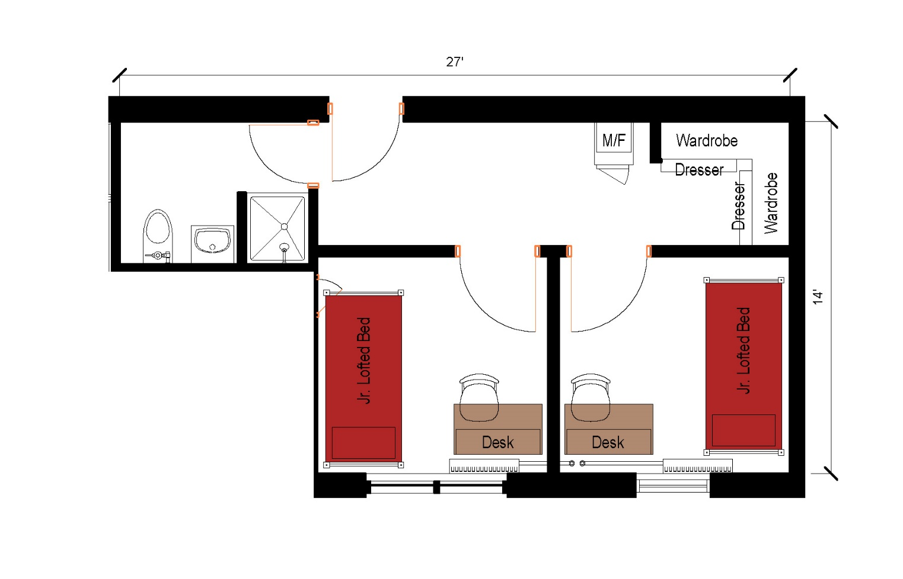

A two bedroom suite that measures 27 feet by 14 feet with a shared bathroom with toilet, sink and shower as well as shared entryway with a microfridge, 2 wardrobes and 2 dressers. Each individual bedroom for one person comes with a junior lofted bed desk and desk chair.
Please note: These floorplans give a close approximation of the space, but your unit’s exact size, layout, and furniture arrangement may vary.

