Archer House

2 people per room with bath and air conditioning
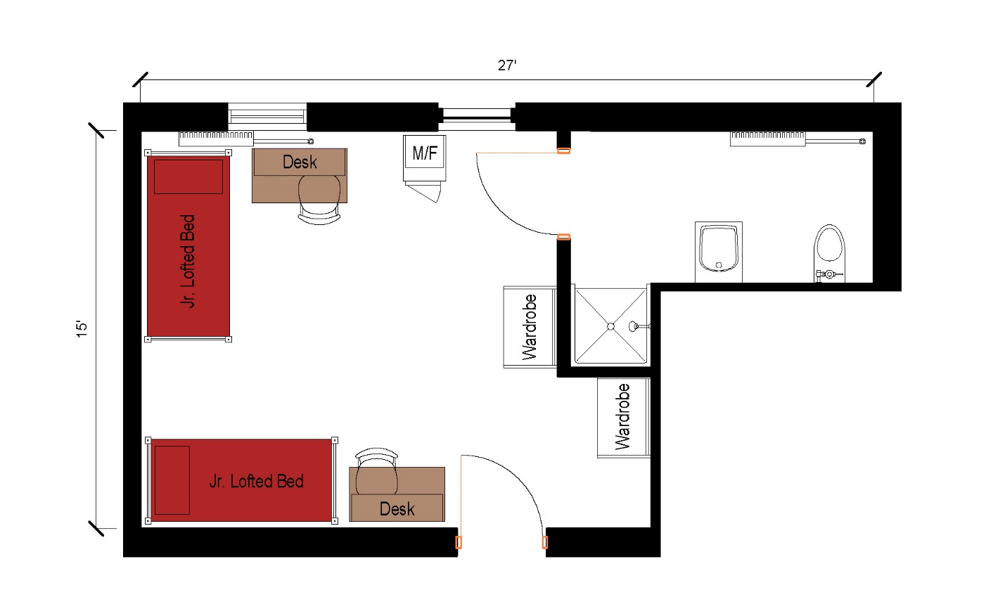
A 2 person room that measures 27 feet by 15 feet. There is a bathroom in the room that includes a sink, toilet, and shower. The room comes with 2 junior lofted beds, 2 desks, 2 desk chairs, 2 wardrobes, and a microfridge.
Please note: These floorplans give a close approximation of the space, but your unit’s exact size, layout, and furniture arrangement may vary.

