Archer House

2 people superdouble loft with bath and air conditioning
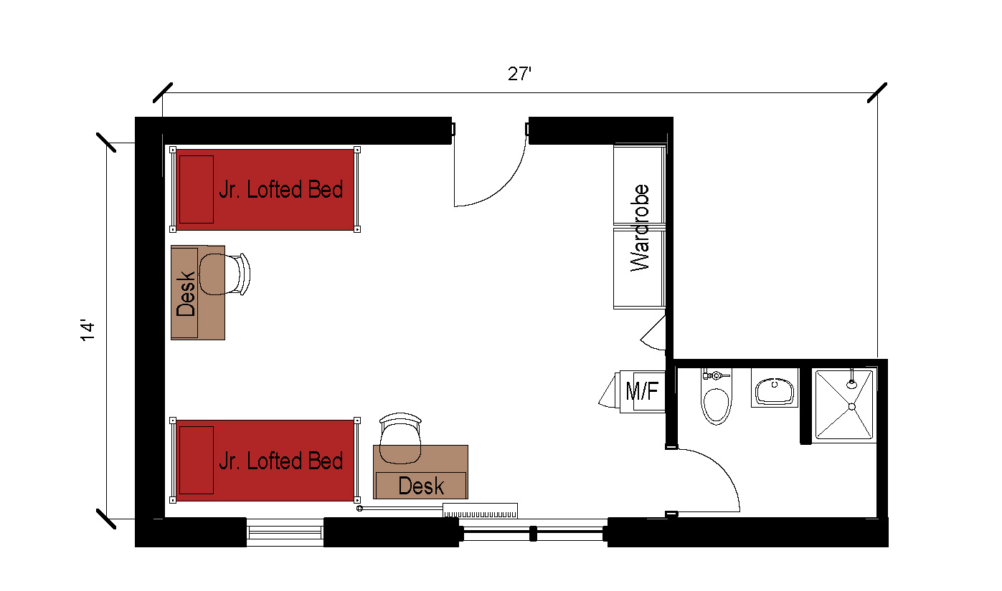
A superdouble loft room for 2 people that measures 27 feet by 14 feet. The room includes a bathroom that has a sink, toilet and shower. The room comes with 2 junior loft beds, 2 desks, 2 desk chairs, 2 wardrobes, and a microfridge.
Please note: These floorplans give a close approximation of the space, but your unit’s exact size, layout, and furniture arrangement may vary.

