Barrett House

2 people per room with bath and air conditioning
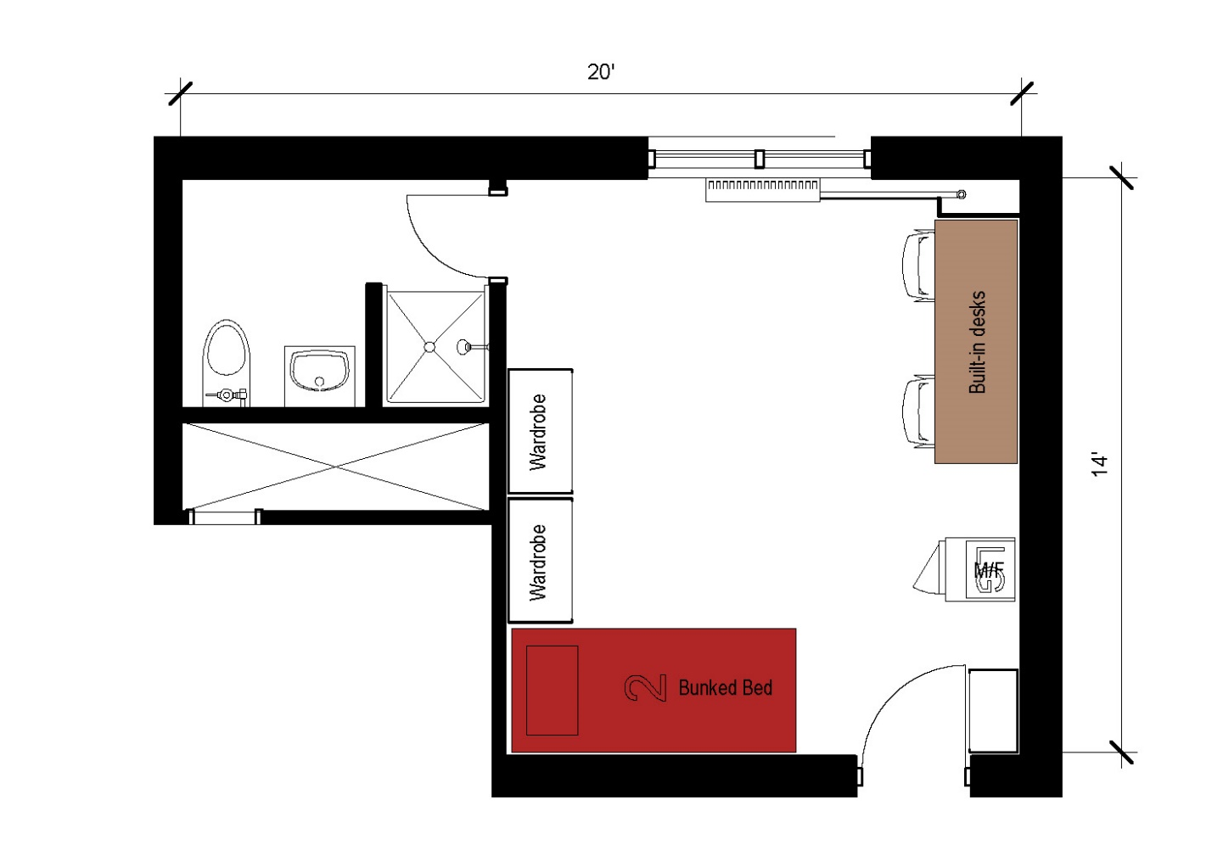
A 2-person room measuring 20 feet by 14 feet that includes a combined sleeping area and study area and bathroom. The room includes 2 beds that are bunked, 2 stand-alone wardrobes. 2 desks built in with 4 desk chairs and a microfridge. The bathroom in the suite includes a toilet, sink and shower.
Please note: These floorplans give a close approximation of the space, but your unit’s exact size, layout, and furniture arrangement may vary.

