Barrett House

4 people per suite with bath and air conditioning
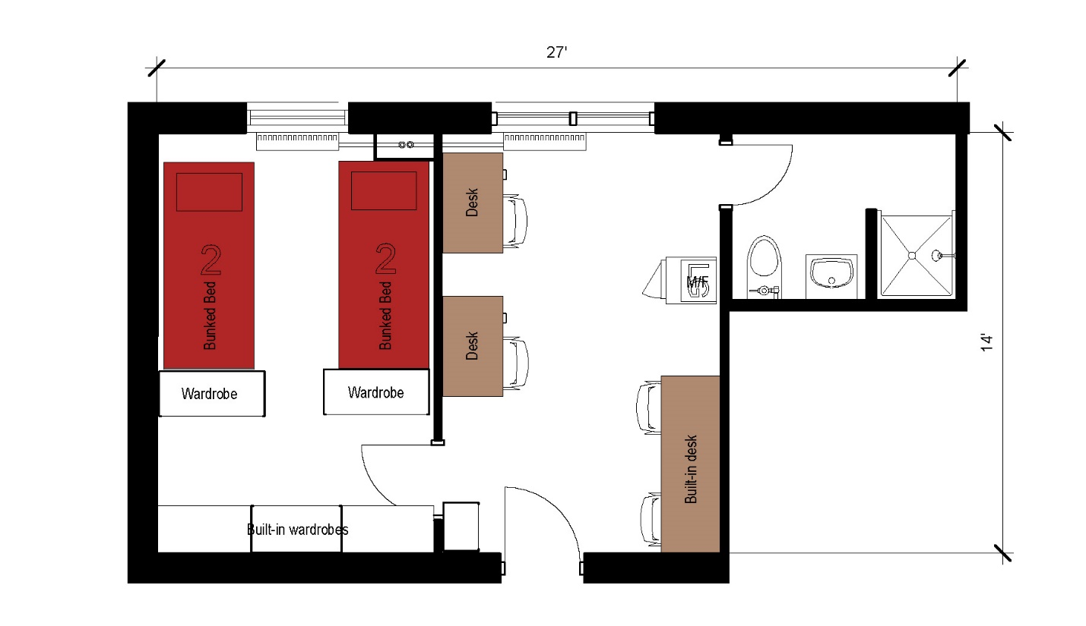

A four person suite measuring 27 feet by 14 feet that includes a sleeping area, study area and bathroom. The sleeping area includes 2 sets of bunked beds, built in wardrobe as well as 2 stand alone wardrobes. In the study area there are 2 desks built in and 2 stand alone desks with 4 desk chairs and a microfridge. The bathroom in the suite includes a toilet, sink and shower.
Please note: These floorplans give a close approximation of the space, but your unit’s exact size, layout, and furniture arrangement may vary.

