Barrett House

4-person apartment
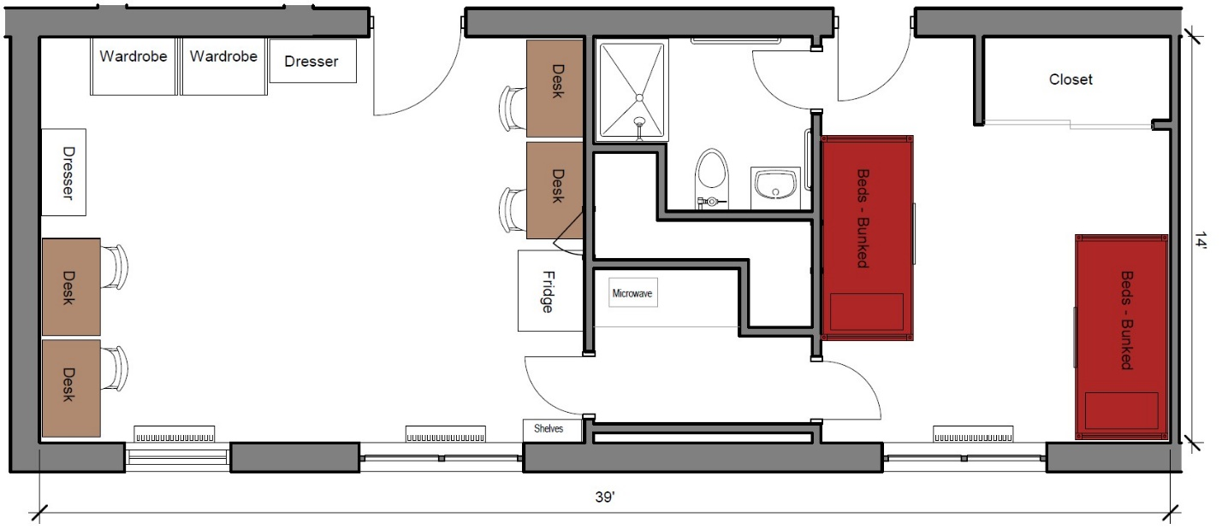

A four-person apartment measuring 39 feet by 14 feet that includes a sleeping area, study area, and bathroom. The sleeping area includes 2 sets of bunked beds and closet as well. In the study area there are 4 desks, 4 desk chairs, 2 wardrobes, 2 closets, full size refrigerator/freezer and microwave and sink. The bathroom in the suite includes a toilet, sink and shower.
Please note: These floorplans give a close approximation of the space, but your unit’s exact size, layout, and furniture arrangement may vary.

