Hanley House

1 person per room with corridor bath and air conditioning
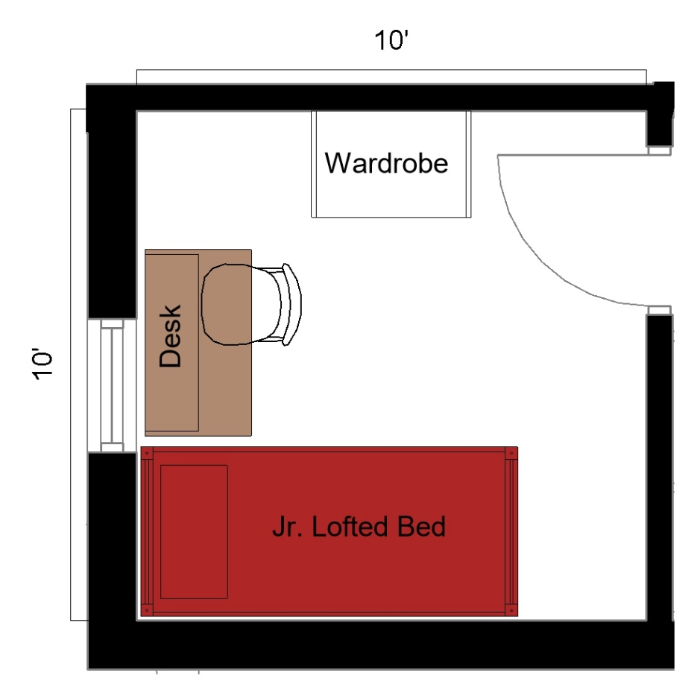
A one-person room with approximate dimensions of 10 feet by 10 feet. The room comes with a junior lofted bed, a desk, desk chair, and a wardrobe.

Please note: These floorplans give a close approximation of the space, but your unit’s exact size, layout, and furniture arrangement may vary.

