Hanley House

3 people per room with corridor bath and air conditioning
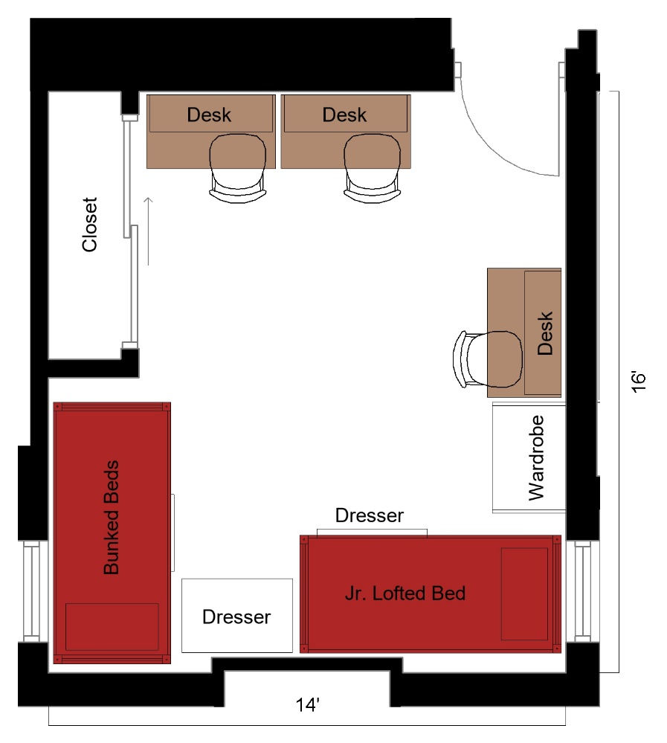
A three-person room with approximate dimensions of 14 feet by 16 feet. The room comes with a junior lofted bed and 2 bunked beds, 3 desks, 3 desk chairs, 2 dressers, 1 closet and 1 wardrobe.

Please note: These floorplans give a close approximation of the space, but your unit’s exact size, layout, and furniture arrangement may vary.

