Houston House

1 person per room with private bath and air conditioning
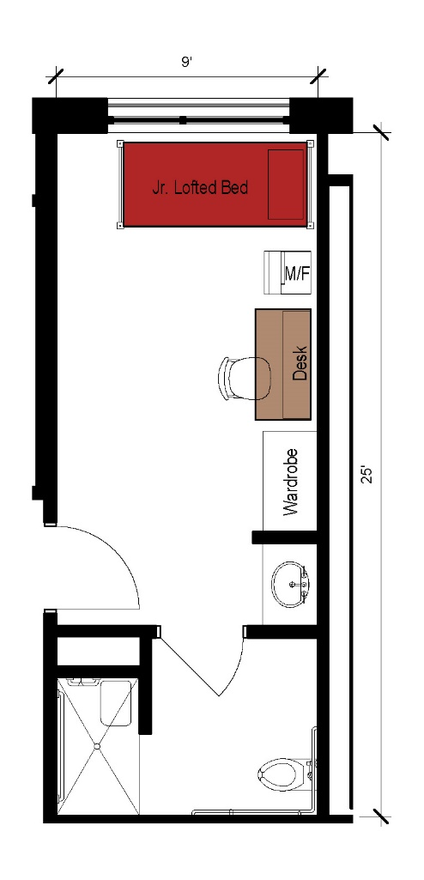
A single room with approximate dimensions of 9 feet by 25 feet that also includes a bathroom (including shower) within the room. The room comes with a junior lofted bed, desk, desk chair, wardrobe as well as a microfridge.

Please note: These floorplans give a close approximation of the space, but your unit’s exact size, layout, and furniture arrangement may vary.

