McConnell Residence Hall

Bathroom

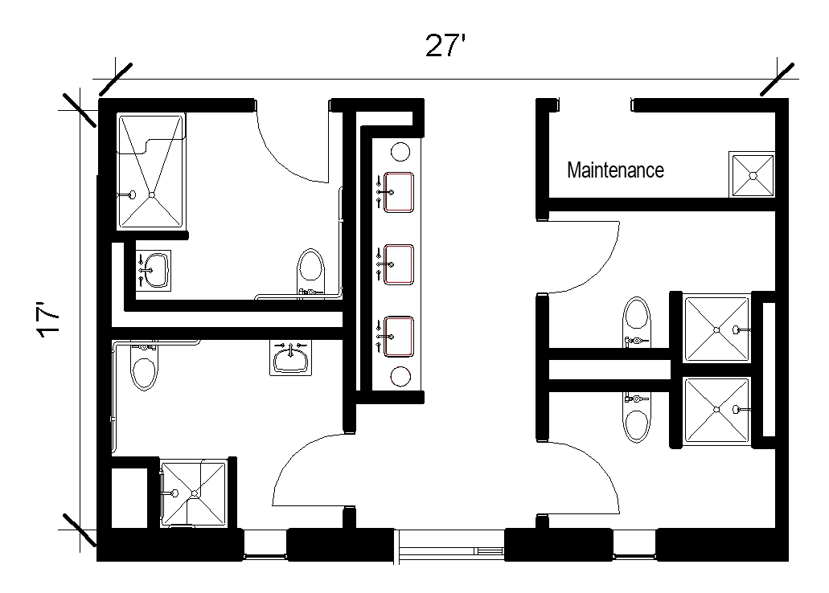
A semi-private bathroom measures approximately 17 feet by 27 feet that includes 4 pods and 3 sinks outside of the pods. Each pod includes a toilet and shower with one of the pods being ADA.
Please note: These floorplans give a close approximation of the space, but your unit’s exact size, layout, and furniture arrangement may vary.

