Morrill Tower

2 people per suite in a 4 suite cluster
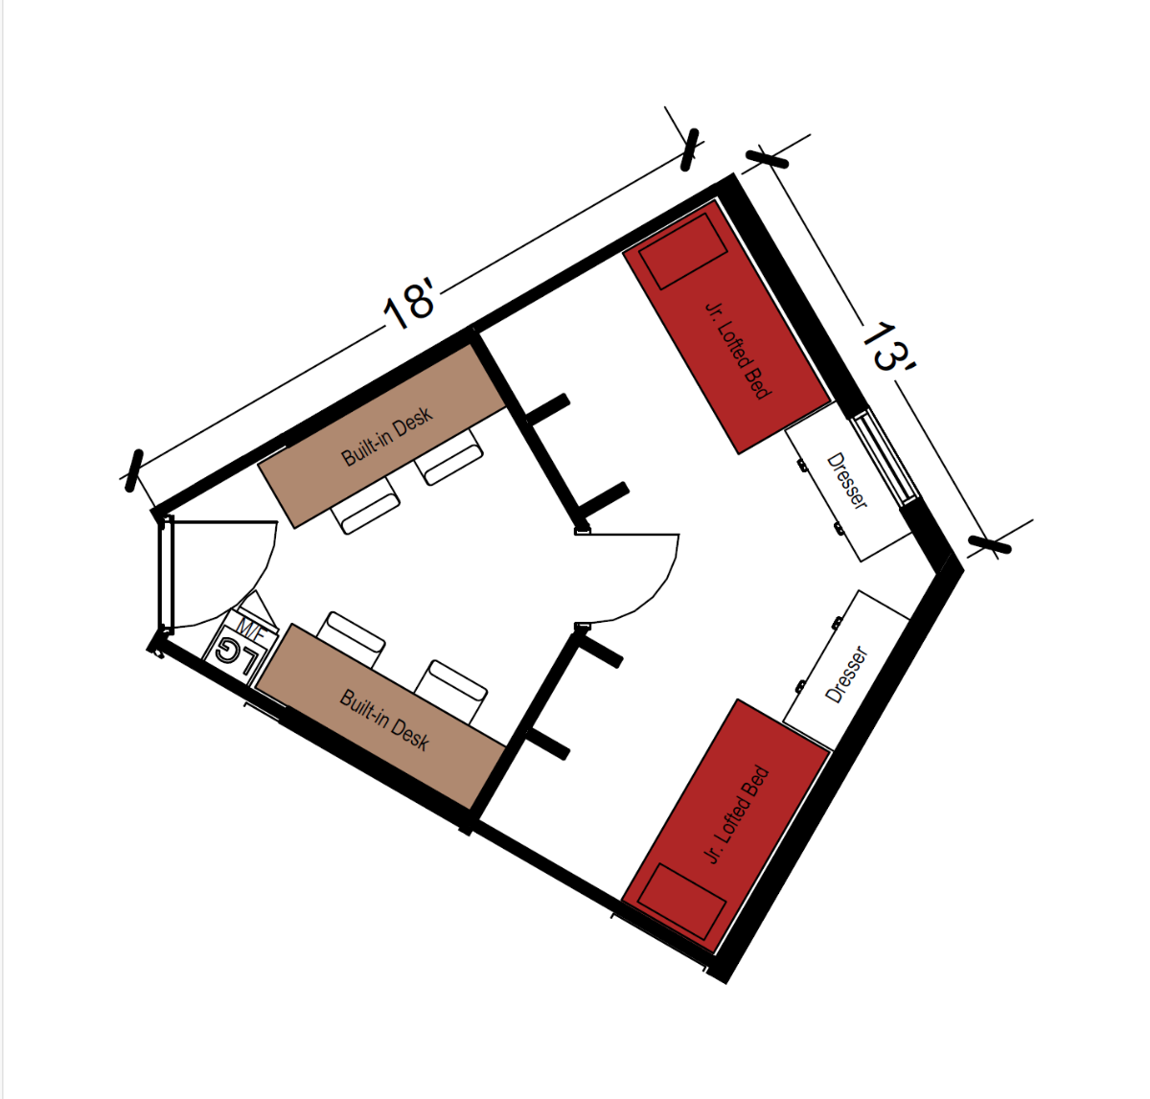
A room for 2 people that measures 18 feet by 13 feet. The room comes with a bedroom area and a study area. In the bedroom area it includes 2 junior lofted beds, 2 built-in dressers and has closets. In the study room area it includes 2 built-in desks, 2 or 4 desk chairs, and a microfridge. The room shares a common area and bathroom with the suite.
Please note: These floorplans give a close approximation of the space, but your unit’s exact size, layout, and furniture arrangement may vary.

