Morrill Tower

1 person room in a 4 suite cluster
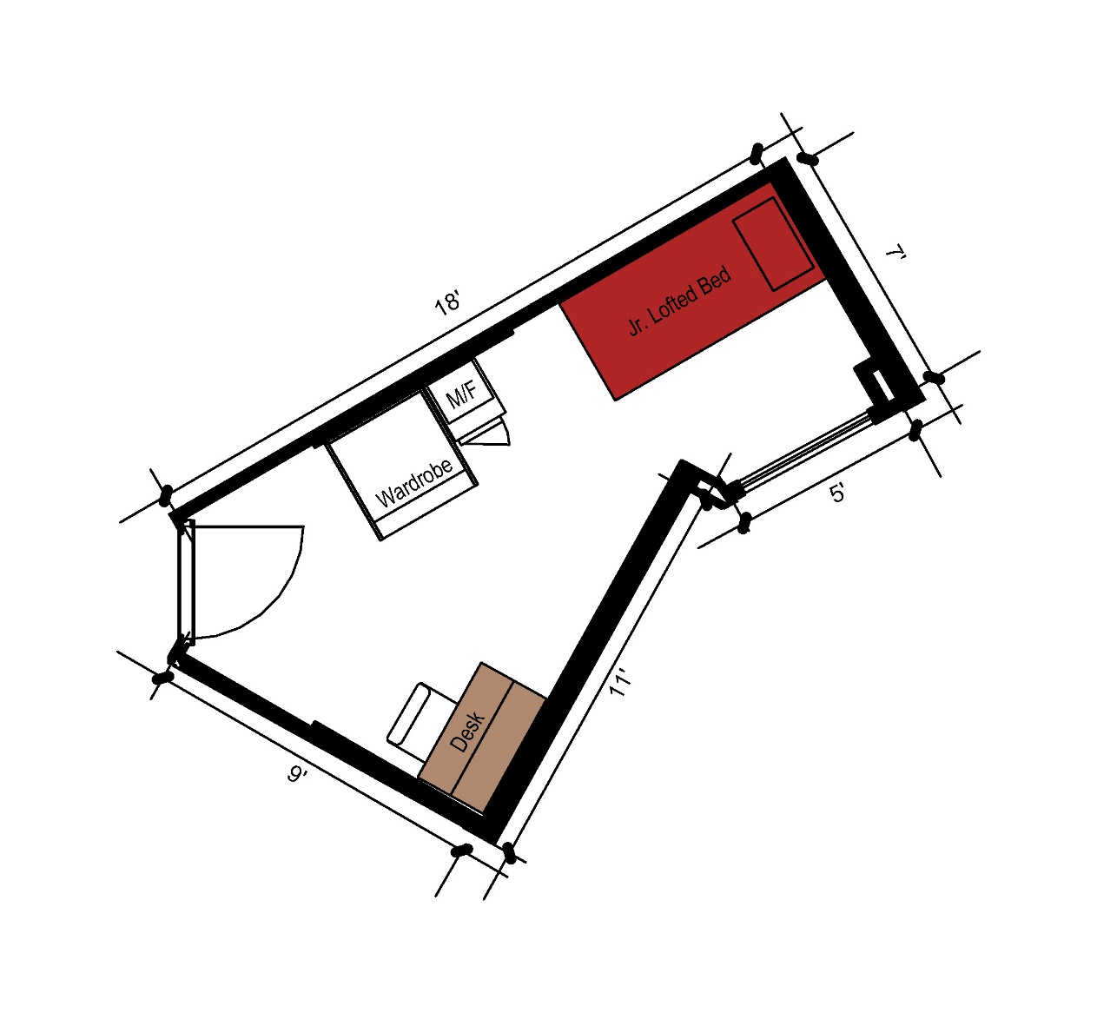
A 1-person room that measures 18 feet by 7 feet. The room includes a junior lofted bed, a desk, desk chair, wardrobe and microfridge. It does share a common room and bathroom with other members of the suite.
Please note: These floorplans give a close approximation of the space, but your unit’s exact size, layout, and furniture arrangement may vary.

