Morrison Tower

3 people per room with corridor bath and air conditioning
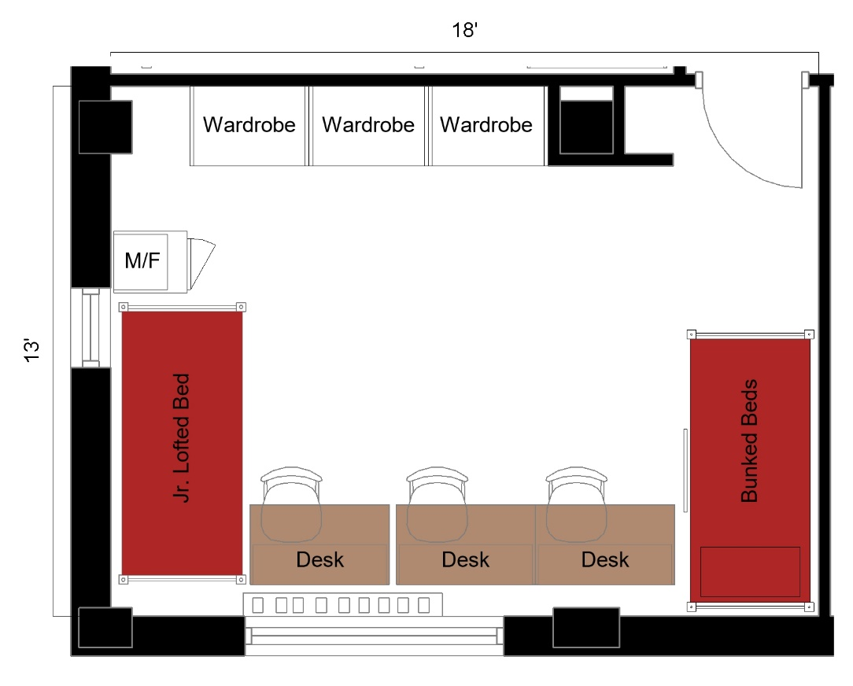

A three-person room measuring 18 feet by 13 feet. The room includes 1 set of bunked beds and 1 junior loft bed, 3 wardrobes, 3 desks, 3 desk chairs and a microfridge.

Please note: These floorplans give a close approximation of the space, but your unit’s exact size, layout, and furniture arrangement may vary.

