Morrison Tower

1 person room with corridor bath and air conditioning
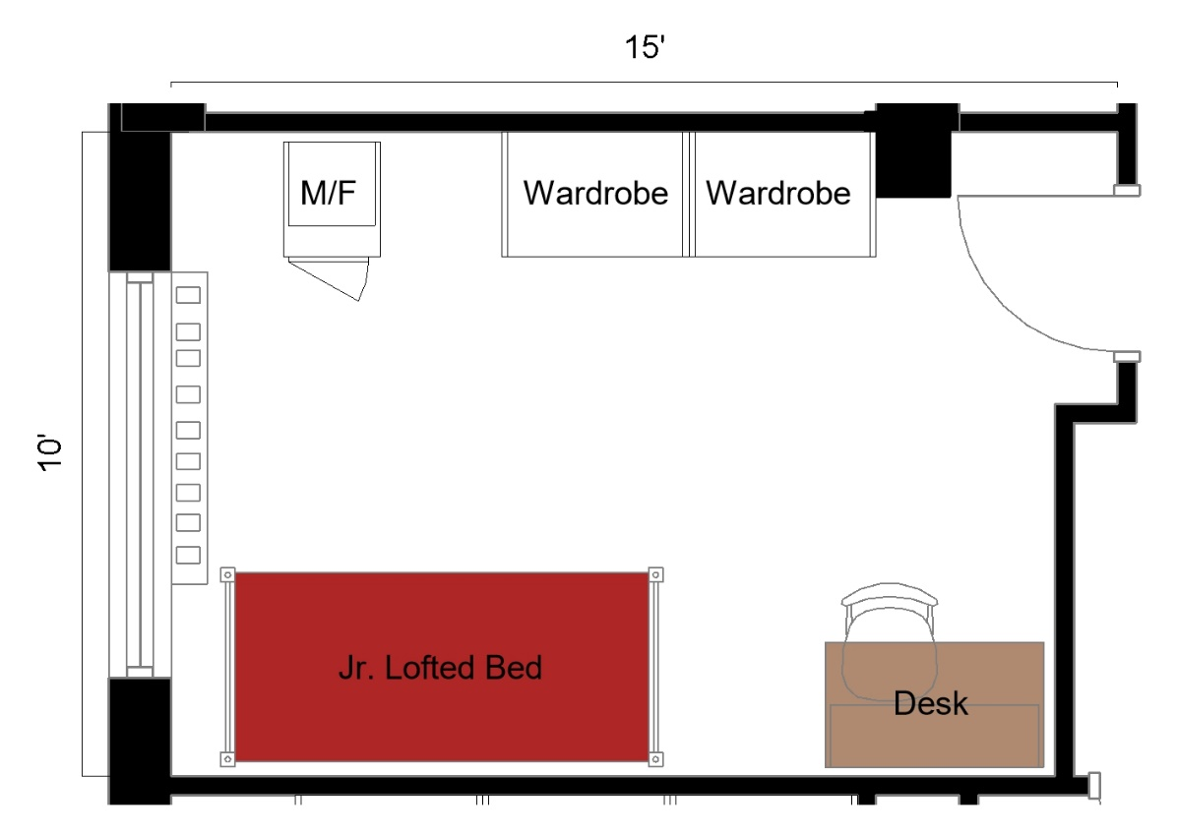

The 1-person room with corridor bath measuring 15 feet by 10 feet. The room included a junior lofted bed, desk, desk chair, 2 wardrobes, and a microfridge.
Please note: These floorplans give a close approximation of the space, but your unit’s exact size, layout, and furniture arrangement may vary.

