Morrison Tower

2 people per room with corridor bath and air conditioning
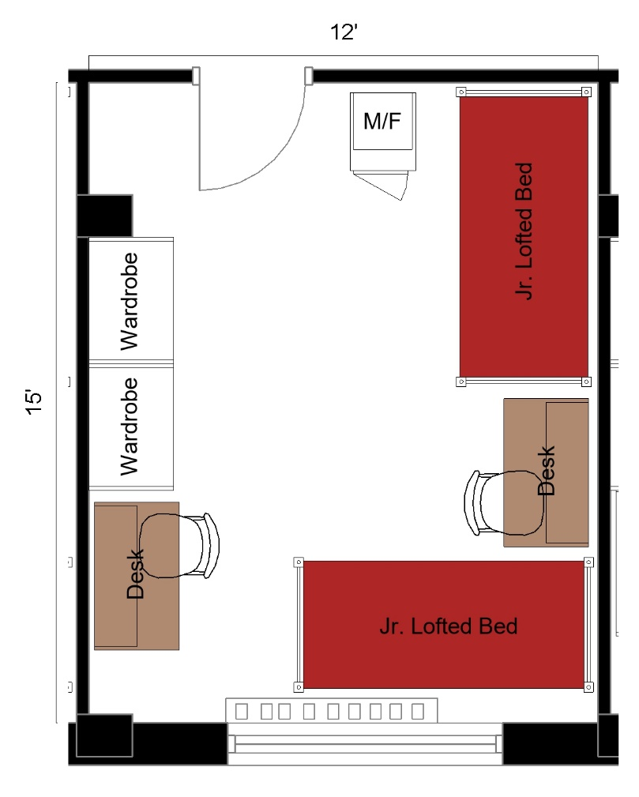

The 2 people per room with corridor bath measuring 15 feet by 12 feet. The room includes 2 junior lofted beds, 2 desks, 2 desk chairs, 2 wardrobes, and a microfridge.
Please note: These floorplans give a close approximation of the space, but your unit’s exact size, layout, and furniture arrangement may vary.

