Morrison Tower

2 people per superdouble with corridor bath and air conditioning
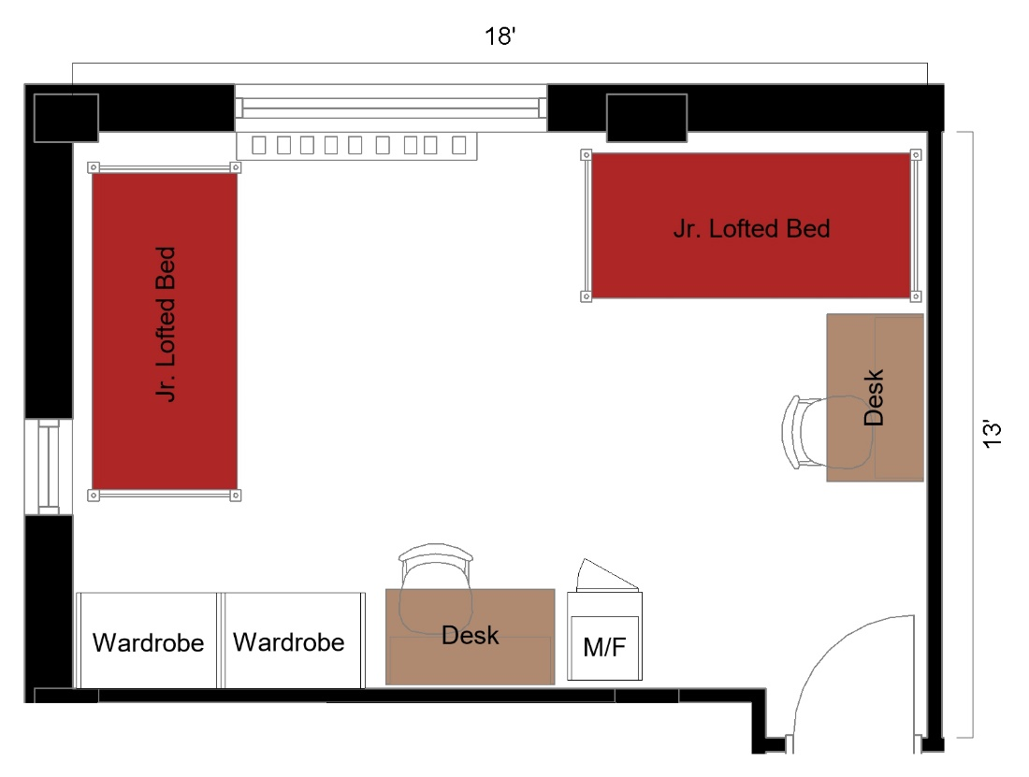

2 people per superdouble room measuring 18 feet by 13 feet. The room includes 2 junior lofted beds, 2 desks, 2 desk chairs, 2 wardrobes, and a microfridge.
Please note: These floorplans give a close approximation of the space, but your unit’s exact size, layout, and furniture arrangement may vary.

