Morrison Tower

1 person room with bath and air conditioning
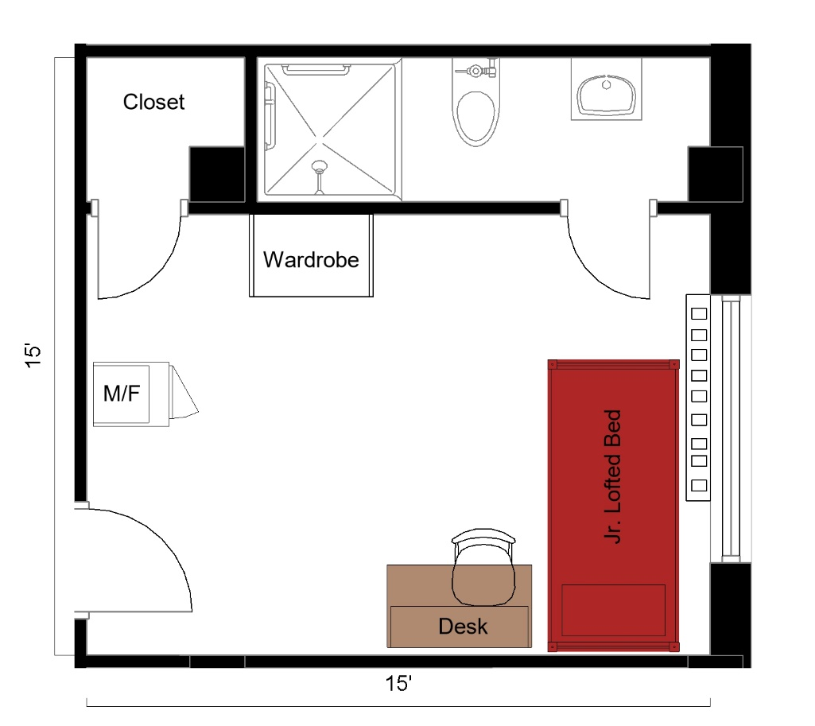

A 1-person room with bath measuring 15 feet by 15 feet. The room includes a junior lofted bed, wardrobe, closet, desk, desk chair and a microfridge. The bathroom includes a sink, toilet and shower.

Please note: These floorplans give a close approximation of the space, but your unit’s exact size, layout, and furniture arrangement may vary.

