Neil Building

Efficiency Apartment
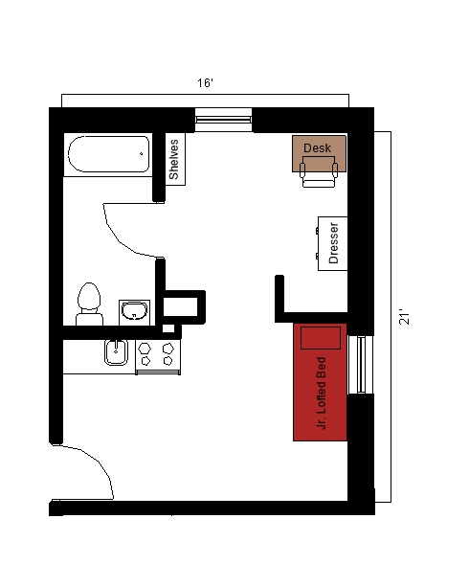
An efficiency apartment with approximate dimensions of 16 feet by 21 feet with a bathroom and small kitchen included. It has a junior lofted bed, a desk and a desk chair, and a dresser and closet. The bathroom has a sink, toilet and shower. The kitchen comes with a stove, sink, microwave, and under the counter refrigerator/freezer.

Please note: These floorplans give a close approximation of the space, but your unit’s exact size, layout, and furniture arrangement may vary.

