Neil Building

2-bedroom apartment for 4 people
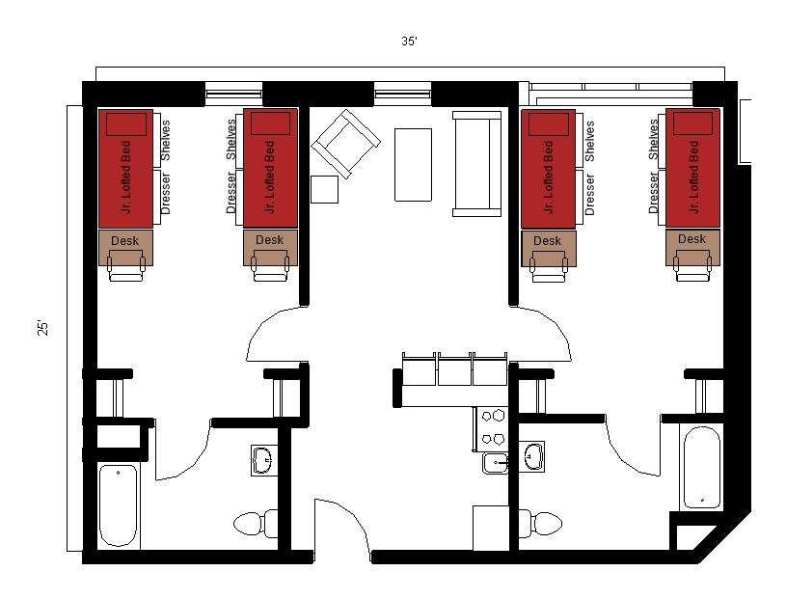
A two-bedroom apartment for 4 people with approximate dimensions of 25 feet by 35 feet with 2 bedrooms, a living room, 2 bathrooms and kitchen included. Each bedroom has 2 junior lofted beds, 2 desks and 2 desk chairs, 2 dressers and 2 closets. Each bathroom has a sink, toilet and shower. The living room has a couch, 2 chairs, a coffee table and end table. The kitchen comes with a stove, refrigerator/freezer, dishwasher and barstools at the counter.

Please note: These floorplans give a close approximation of the space, but your unit’s exact size, layout, and furniture arrangement may vary.

