Mendoza House

Efficiency apartment for 2 people with air conditioning
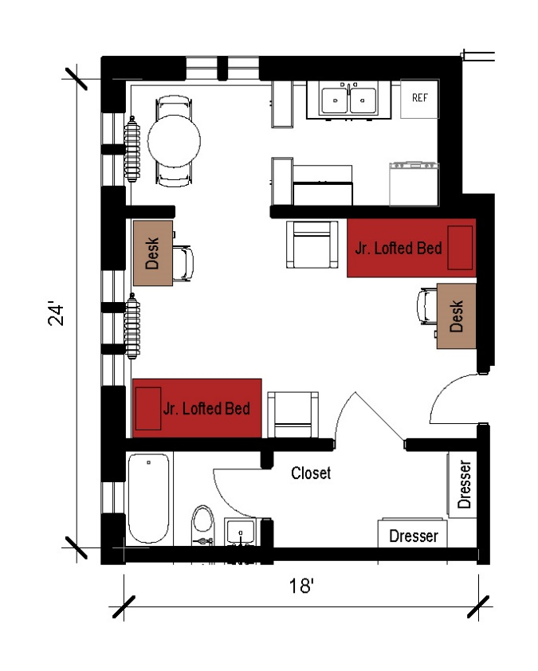
An efficiency apartment measuring 24 feet by 18 feet. It has a bathroom with a toilet, sink and shower. It includes a closet and 2 dressers as well as 2 junior lofted beds, 2 desks, 2 desk chairs and a lounge chair. The efficiency has a kitchen with a table and chairs, sink, refrigerator, and stove. It comes with an air conditioning unit provided by the university.

Please note: These floorplans give a close approximation of the space, but your unit’s exact size, layout, and furniture arrangement may vary.

