Newark Apartments

Efficiency Apartment for 2 people
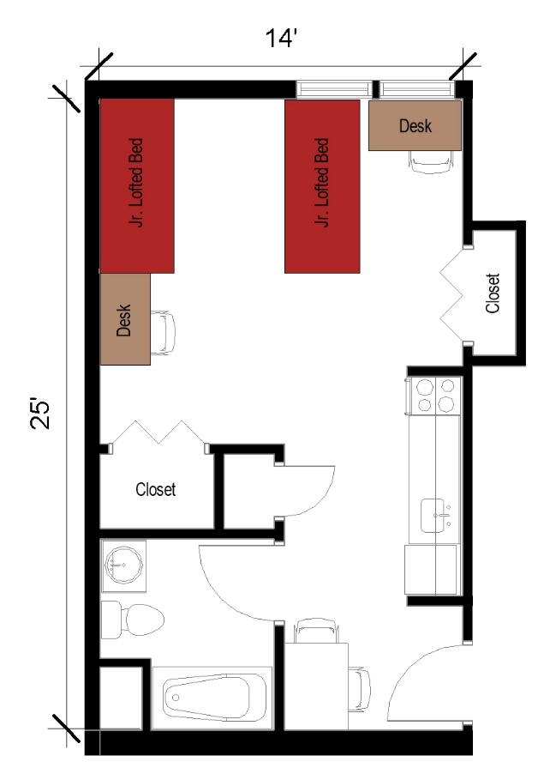
A two-person efficiency with approximate dimensions of 14 feet by 25 feet which includes a bathroom and kitchen. The room comes with 2 junior lofted beds, 2 desks, 2 desk chairs, and 2 closets. The bathroom has a sink, toilet and shower. The kitchen comes with a sink, stove, refrigerator/freezer and a table with two chairs.

Please note: These floorplans give a close approximation of the space, but your unit’s exact size, layout, and furniture arrangement may vary.

