Newark Apartments

2-bedroom apartment for 4 people
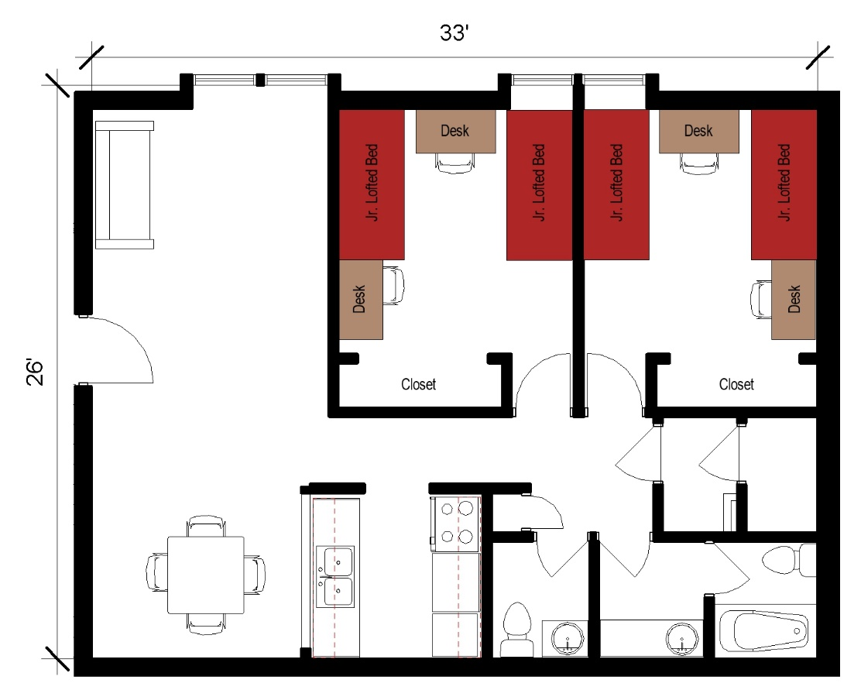
A two-bedroom apartment for 4 people with approximate dimensions of 26 feet by 33 feet with 2 bedrooms, a living room, 1 full bathroom and 1 half bathroom, and kitchen included. Each bedroom has 2 junior lofted beds, 2 desks and 2 desk chairs, and 2 closets. The full bathroom has a sink, toilet and shower while the half bathroom only has a sink and toilet. The living room has a couch. The kitchen comes with a stove, refrigerator/freezer, and a table and 4 chairs.

Please note: These floorplans give a close approximation of the space, but your unit’s exact size, layout, and furniture arrangement may vary.

