Norton House

2 people per superdouble with bath and air conditioning
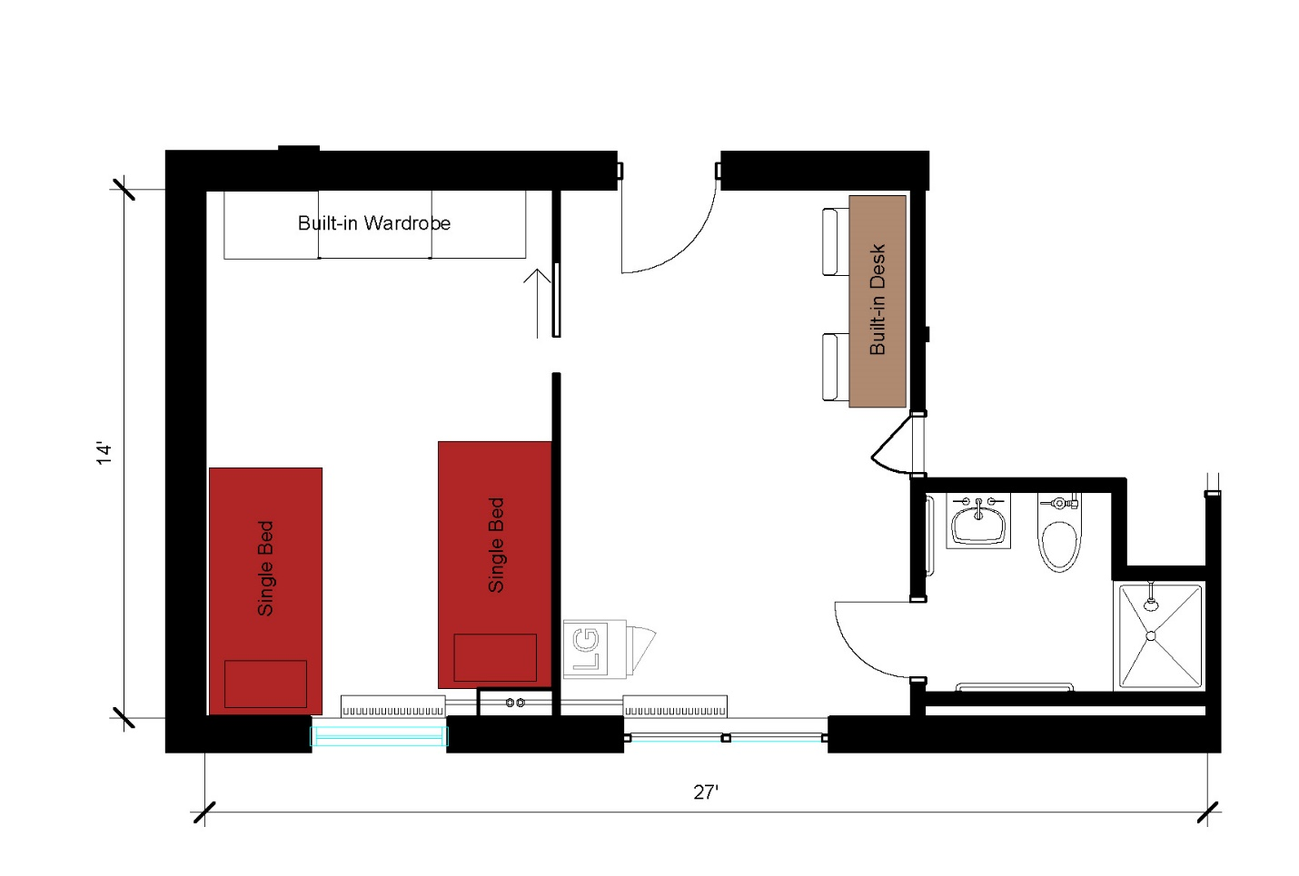
A two-person superdouble suite measuring 27 feet by 14 feet that includes a sleeping area, study area and bathroom. The sleeping area includes 2 single beds and a built-in wardrobe. In the study area there are 2 built-in desks with 2 desk chairs and a microfridge. The bathroom in the suite includes a toilet, sink and shower.
Please note: These floorplans give a close approximation of the space, but your unit’s exact size, layout, and furniture arrangement may vary.

