Park-Stradley Hall

Bathroom Type B
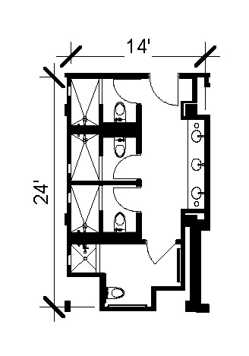
A semi-private bathroom measures approximately 14 feet by 24 feet that includes 4 pods and 4 sinks outside of the pods. Each pod includes a toilet and shower with one of the pods being ADA.
Please note: These floorplans give a close approximation of the space, but your unit’s exact size, layout, and furniture arrangement may vary.

