Park-Stradley Hall

2 people per room with semi-private bath and air conditioning-original wing
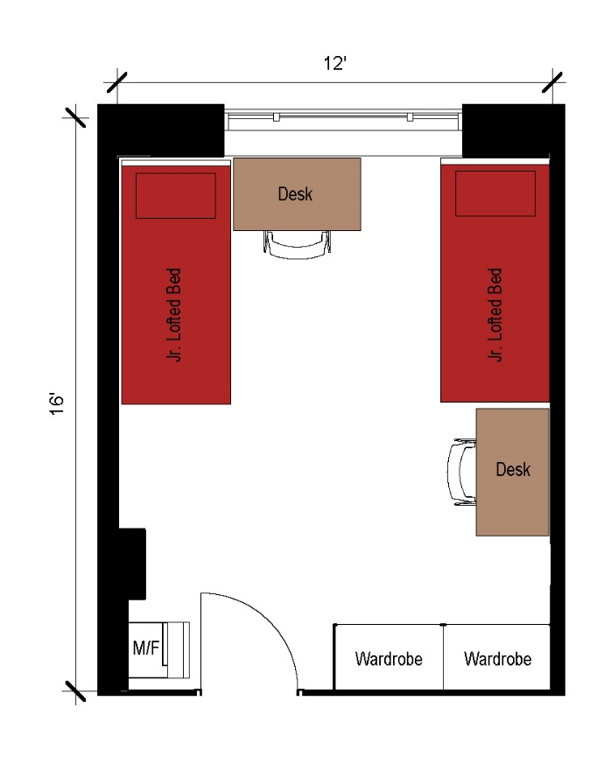
A two-person room with approximate dimensions of 12 feet by 16 feet. The room comes with 2 junior lofted beds, 2 desks, 2 desk chairs, 2 wardrobes and a microfridge.

Please note: These floorplans give a close approximation of the space, but your unit’s exact size, layout, and furniture arrangement may vary.

