Master Lease: Point on Lane

4-person apartment Type 202
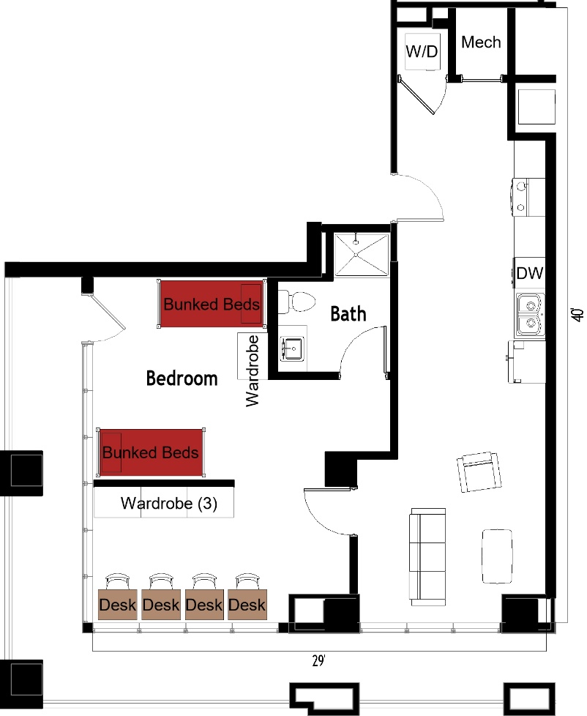
The 4-person apartment (Type 202) measures 29 feet by 40 feet. The bedroom includes 2 sets of bunked beds, has 4 wardrobes, 4 desks, 4 desk chairs. The bathroom includes a sink, toilet and shower. The living room has a couch, chair and coffee table. The kitchen has a refrigerator/freezer, sink, stove and dishwasher. There is a washer and dryer provided in the apartment.

Please note: These floorplans give a close approximation of the space, but your unit’s exact size, layout, and furniture arrangement may vary.

