Master Lease: Point on Lane

2 people per room in 3-bedroom apartment Type 240
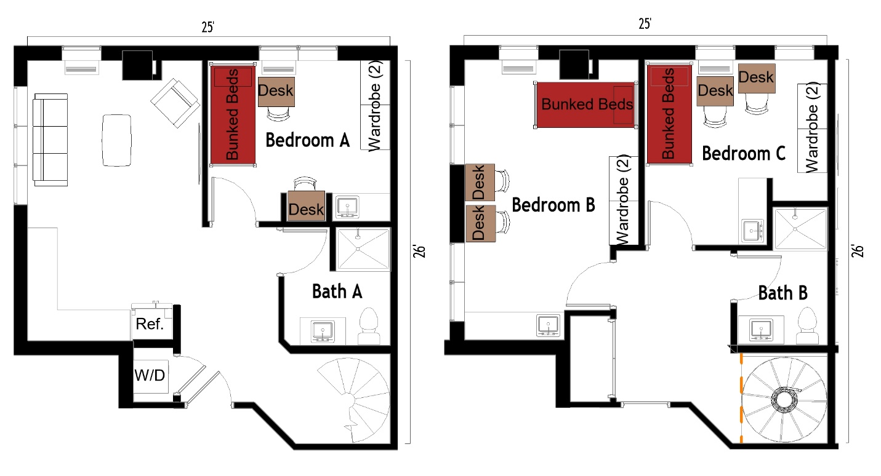

The 2 people per room in a 3-bedroom apartment (Type 240) measures 25 feet by 26 feet and is two levels. Each bedroom has a set of bunked beds, 2 desks, 2 desk chairs, 2 wardrobes. There are 2 bathrooms, each has a sink, toilet, and shower. In the living room there is a couch, chair, and coffee table. The kitchen comes with a refrigerator/freezer, sink, stove. There is a washer and dryer in the unit.
Please note: These floorplans give a close approximation of the space, but your unit’s exact size, layout, and furniture arrangement may vary.

