Master Lease: Point on Lane

5-bedroom apartment for 14 Type 304
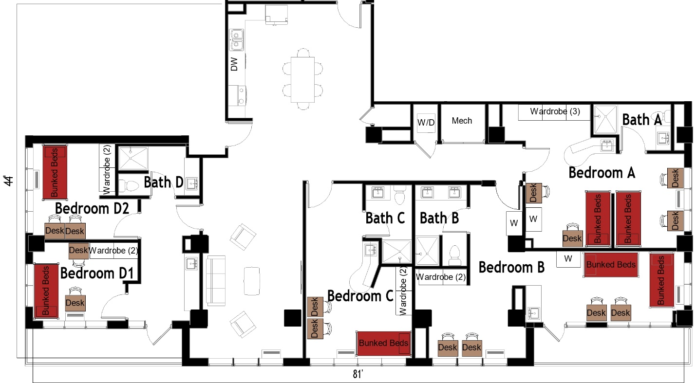

The 5-bedroom apartment for 14 (Type 304) measures 44 feet by 81 feet. Each bedroom has 1or 2 sets of bunked beds, 2-4 desks, 2-4 desk chairs, 2-4 wardrobes. There are 4 bathrooms, each has a sink, toilet, and shower. In the living room there is a couch, 2 chairs, and coffee table. The kitchen comes with a refrigerator/freezer, sink, stove, and dishwasher. There is a table with chairs. There is a washer and dryer in the unit.
Please note: These floorplans give a close approximation of the space, but your unit’s exact size, layout, and furniture arrangement may vary.

