Master Lease: Point on Lane

2 people per room with bath in a 4-bedroom apartment Type 426
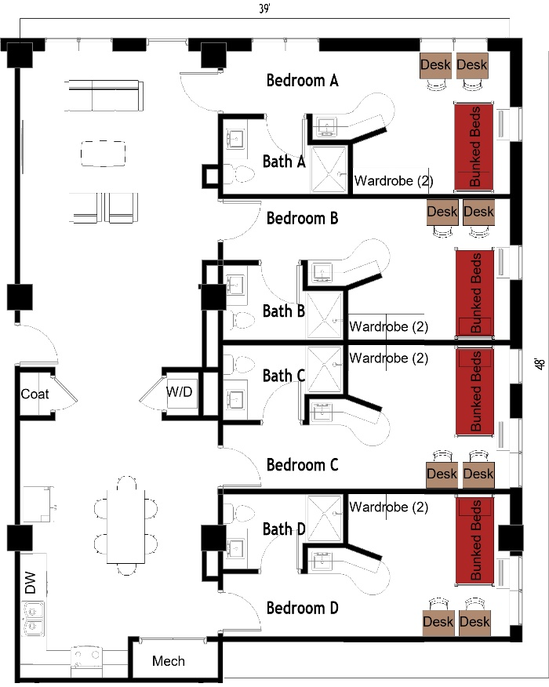

The 2 people per room in a 4-bedroom apartment (Type 426) measure 39 feet by 48 feet. Each bedroom has a set of bunked beds, 2 desks, 2 desk chairs, 2 wardrobes. There are 3 bathrooms, each has a sink, toilet, and shower. In the living room there is a couch, 2 chairs, and coffee table. The kitchen comes with a refrigerator/freezer, sink, stove, and dishwasher. There is a table with chairs. There is a washer and dryer in the unit.
Please note: These floorplans give a close approximation of the space, but your unit’s exact size, layout, and furniture arrangement may vary.

The 3-bedroom apartment for 5 (Type 423) measures 37 feet by 31 feet. Each bedroom has either a set of bunked beds or a junior loft bed, 1-2 desks, 1-2 desk chairs, 1-2 wardrobes. There are 3 bathrooms, each has a sink, toilet, and shower. In the living room there is a couch, a chair, and coffee table. The kitchen comes with a refrigerator/freezer, sink, stove, and dishwasher. There is a table with chairs. There is a washer and dryer in the unit.
Please note: These floorplans give a close approximation of the space, but your unit’s exact size, layout, and furniture arrangement may vary.

