Master Lease: Point on Lane

2 people per room with bath in a 2-bedroom apartment Type 519
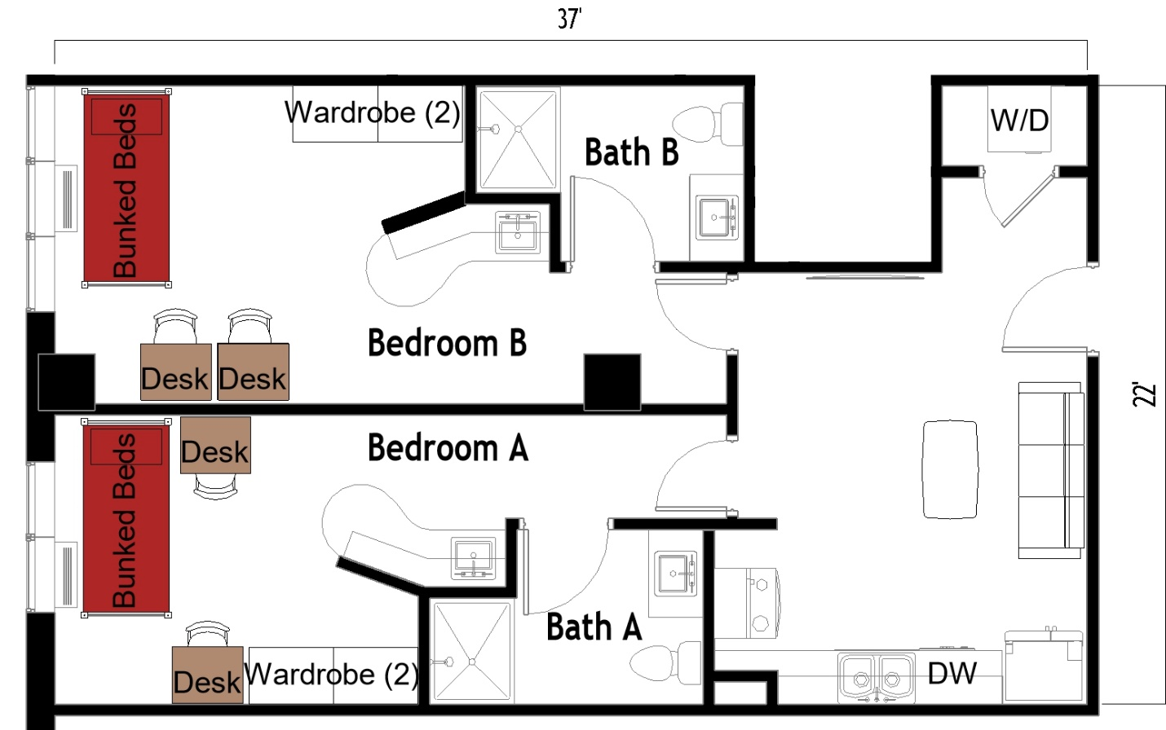

The 2 people per room in a 2-bedroom apartment (Type 519) measures 37 feet by 22 feet. Each bedroom has a set of bunked beds, 2 desks, 2 desk chairs, 2 wardrobes. There are 2 bathrooms, each has a sink, toilet, and shower. In the living room there is a couch and coffee table. The kitchen comes with a refrigerator/freezer, sink, stove, and dishwasher. There is a table with chairs. There is a washer and dryer in the unit.
Please note: These floorplans give a close approximation of the space, but your unit’s exact size, layout, and furniture arrangement may vary.

