Master Lease: Point on Lane

2-bedroom apartment for 6 Type 614
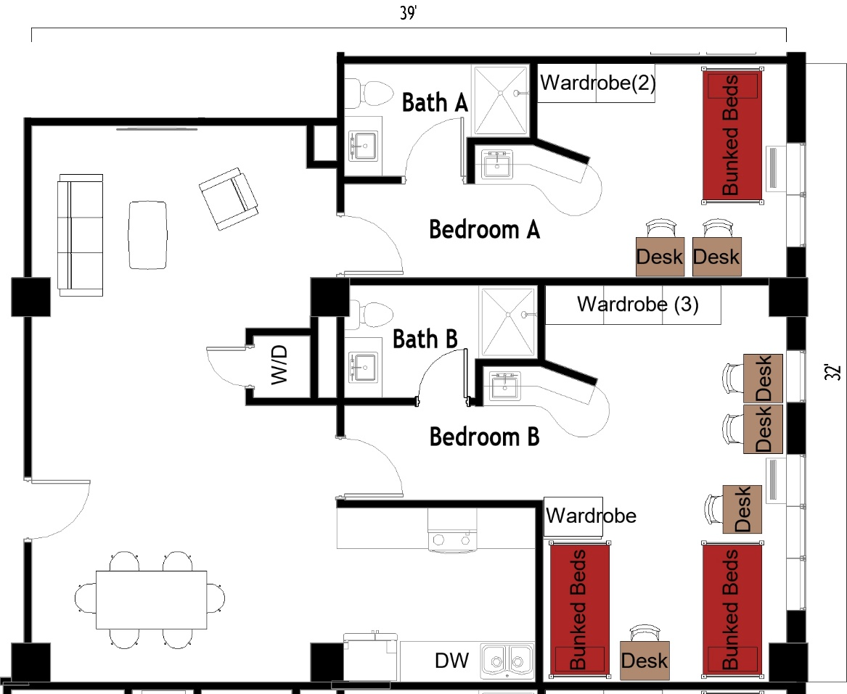

The 2-bedroom apartment for 6 (Type 614) measures 39 feet by 37 feet. Each bedroom has either 1 or 2 sets of bunked beds, 2-4 desks, 2-4 desk chairs, 2-4 wardrobes. There are 2 bathrooms, each has a sink, toilet, and shower. In the living room there is a couch, a chair, and coffee table. The kitchen comes with a refrigerator/freezer, sink, stove, and dishwasher. There is a table with chairs. There is a washer and dryer in the unit.
Please note: These floorplans give a close approximation of the space, but your unit’s exact size, layout, and furniture arrangement may vary.

