Master Lease: Point on Lane

3-bedroom apartment for 6 Type 718
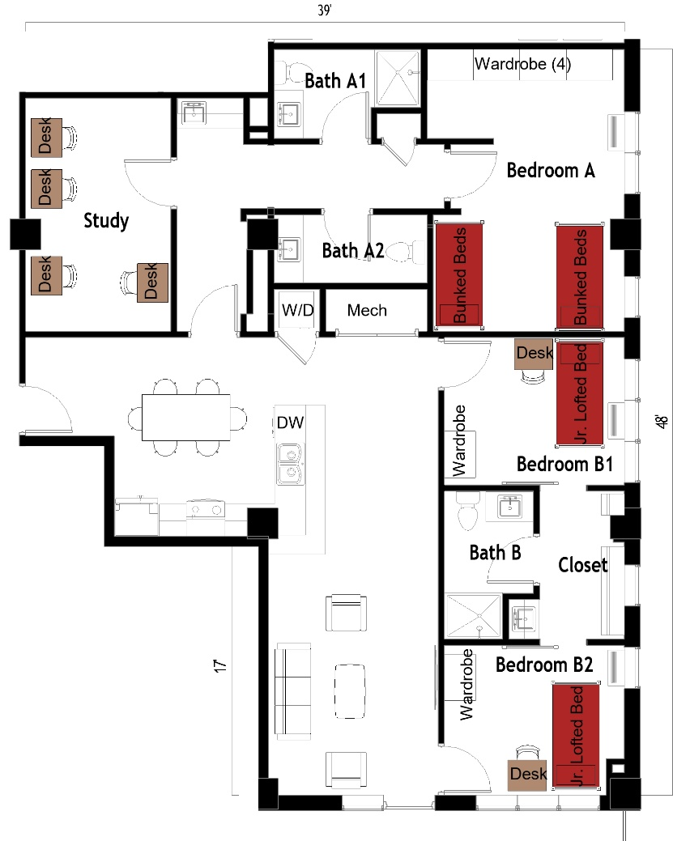
The 3-bedroom apartment for 6 (Type 718) measures 39 feet by 48 feet. Each bedroom has either 2 sets of bunked beds or a junior loft bed, 1-4 desks, 1-4 desk chairs, 1-4 wardrobes. There are 3 bathrooms, each has a sink, toilet, and shower. In the living room there is a couch, 2 chairs, and coffee table. The kitchen comes with a refrigerator/freezer, sink, stove, and dishwasher. There is a table with chairs. There is a washer and dryer in the unit.
Please note: These floorplans give a close approximation of the space, but your unit’s exact size, layout, and furniture arrangement may vary

