Scott House

2 people per room with semi-private bath and air conditioning
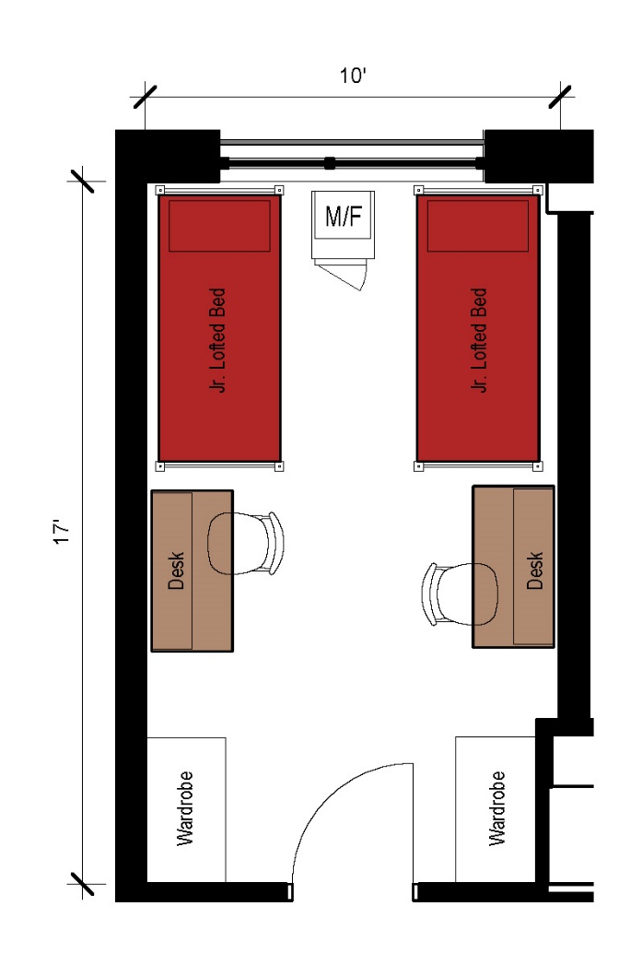
A double room with approximate dimensions of 17 feet by 10 feet. The room comes with two junior lofted beds, 2 desks, 2 desk chairs, 2 wardrobes as well as a microfridge.

Please note: These floorplans give a close approximation of the space, but your unit’s exact size, layout, and furniture arrangement may vary.

