North Residential Semi-Private Bathroom

Semi-Private Bathrooms
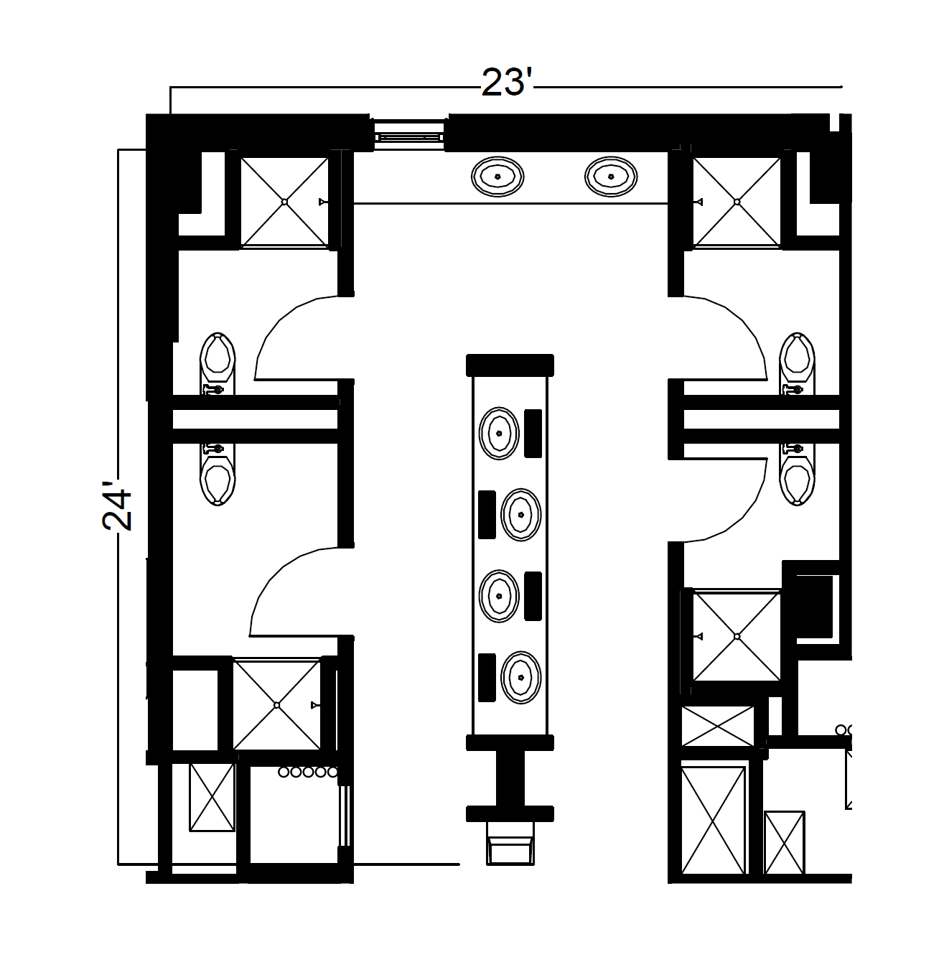
A semi-private restroom found in the hallway that measures 24 feet by 23 feet includes 4 sinks and vanities in the center along with two additional sinks along the back wall. 2 single occupancy spaces on each side of the center sinks include a toilet and shower behind each door for private use.

