Raney House

2 people per bedroom in a 2 room suite with a shared bath, lounge, and air conditioning
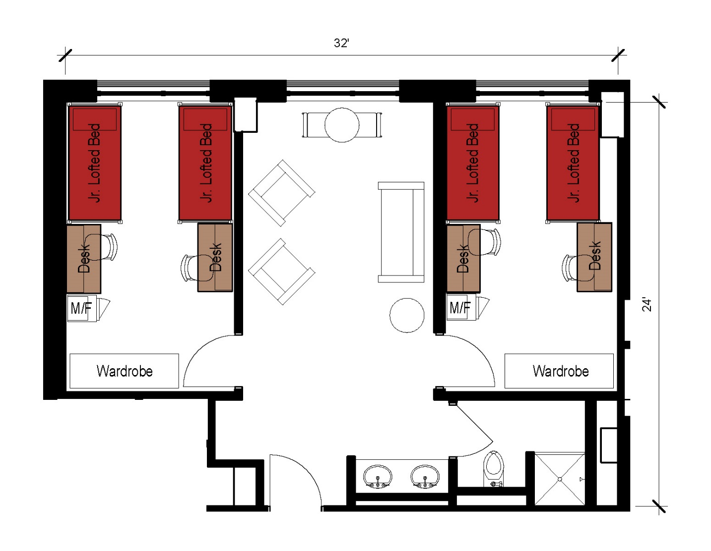
A suite with 2 separate bedrooms with each bedroom being assigned to 2 students with the suite approximate dimensions of 32 feet by 24 feet that also includes a shared bathroom (including shower) and a lounge within the suite. Each bedroom comes with 2 junior lofted beds, 2 desks, 2 desk chairs, 2 wardrobes as well as a microfridge.
Please note: These floorplans give a close approximation of the space, but your unit’s exact size, layout, and furniture arrangement may vary.

