Raney House

2 people per bedroom in a 2-room suite with a shared bath and air conditioning
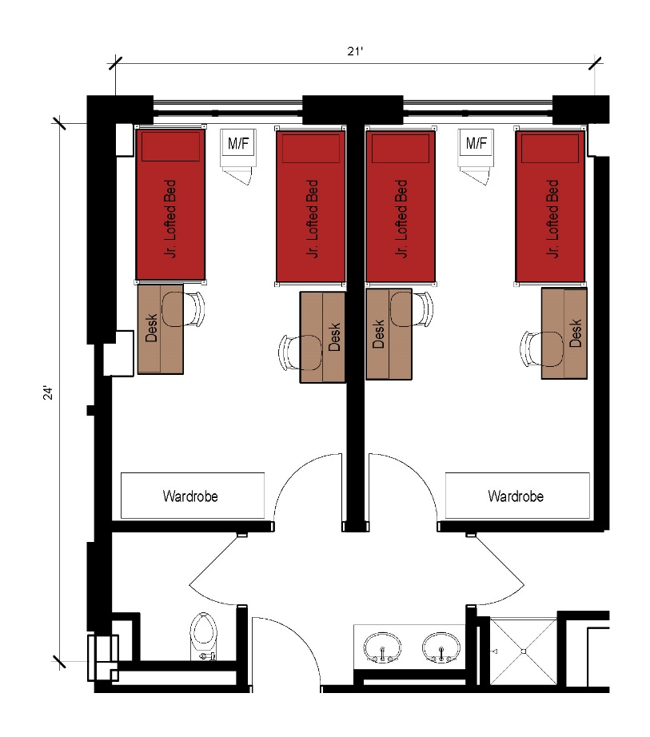
A suite with 2 separate bedrooms with each bedroom being assigned to 2 students with the suite approximate dimensions of 24 feet by 21 feet that also includes a shared bathroom (including shower) within the suite. Each bedroom comes with 2 junior lofted beds, 2 desks, 2 desk chairs, 2 wardrobes as well as a microfridge.

Please note: These floorplans give a close approximation of the space, but your unit’s exact size, layout, and furniture arrangement may vary.

