The Residence on 10th

2 people per room with bath and air conditioning
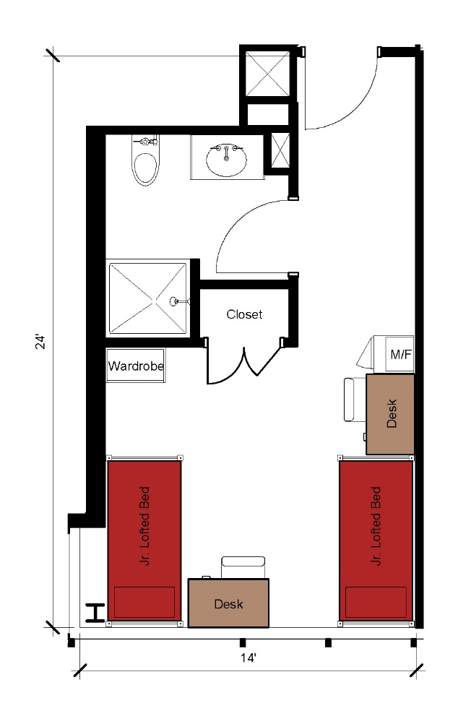
The 2-person room measures 24 feet by 14 feet. The room includes a bathroom with a sink, toilet, and shower. The room also includes 2 junior lofted beds, 2 desks, 2 desk chairs, 1 closet and 1 wardrobe, and a microfridge.
Please note: These floorplans give a close approximation of the space, but your unit’s exact size, layout, and furniture arrangement may vary.

