The Residence on 10th

2 people per bedroom in a 3-room suite with a shared bath, lounge, and air conditioning
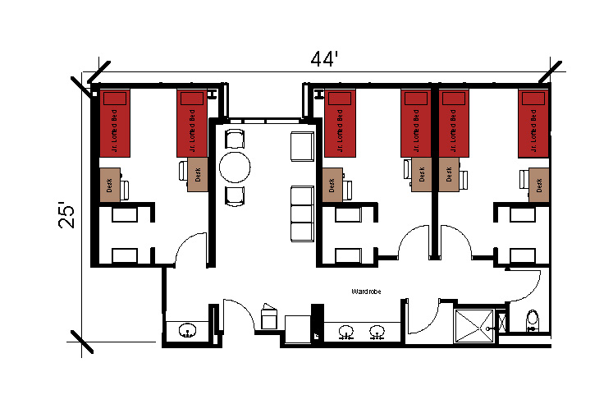
A suite with 3 separate bedrooms with 2 people per bedroom with the measuring 25 feet by 44 feet. The suite includes a shared bathroom with a toilet, shower and 3 sinks. It also has a lounge that comes with a couch, table and chairs and a lounge chair and refrigerator. In the bedrooms there are 2 junior lofted beds, 2 desks, 2 desk chairs, and 2 built-in wardrobes.
Please note: These floorplans give a close approximation of the space, but your unit’s exact size, layout, and furniture arrangement may vary.

