Scholars House East

Bathroom Diagram
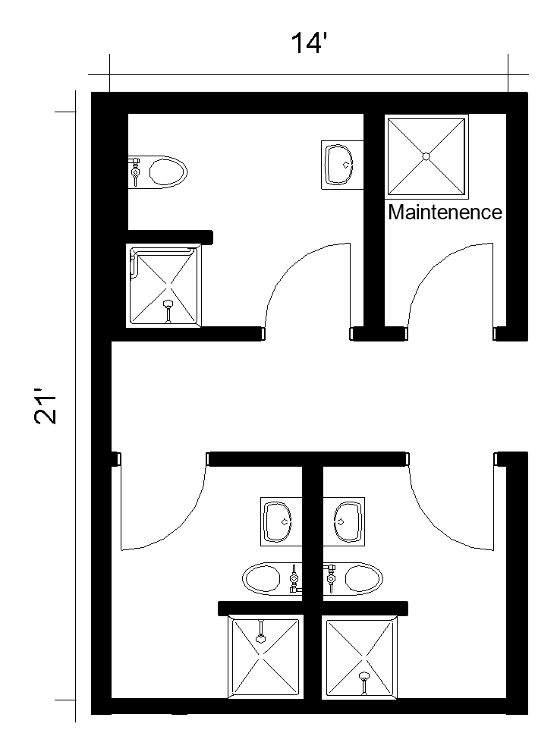
Each bathroom pod includes a sink, toilet and shower and there are 3 pods within the restroom.
Please note: These floorplans give a close approximation of the space, but your unit’s exact size, layout, and furniture arrangement may vary.

