Siebert Hall

Siebert Bathroom Diagram
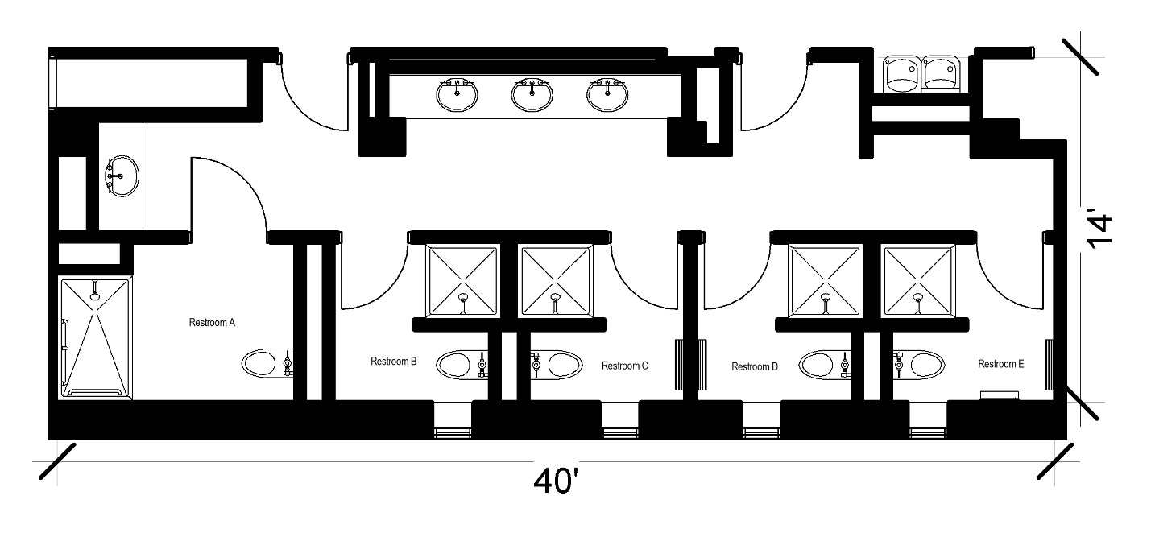
A Siebert Hall bathroom that measures 14 feet by 40 feet and includes 5 pods and sinks separate. Each pod includes a toilet and shower and one of the pods is an ADA pod. There are 4 sinks separate from the pods.

Please note: These floorplans give a close approximation of the space, but your unit’s exact size, layout, and furniture arrangement may vary.

