Master Lease: StateHouse Highline

1 bedroom apartment for 2-Type A2
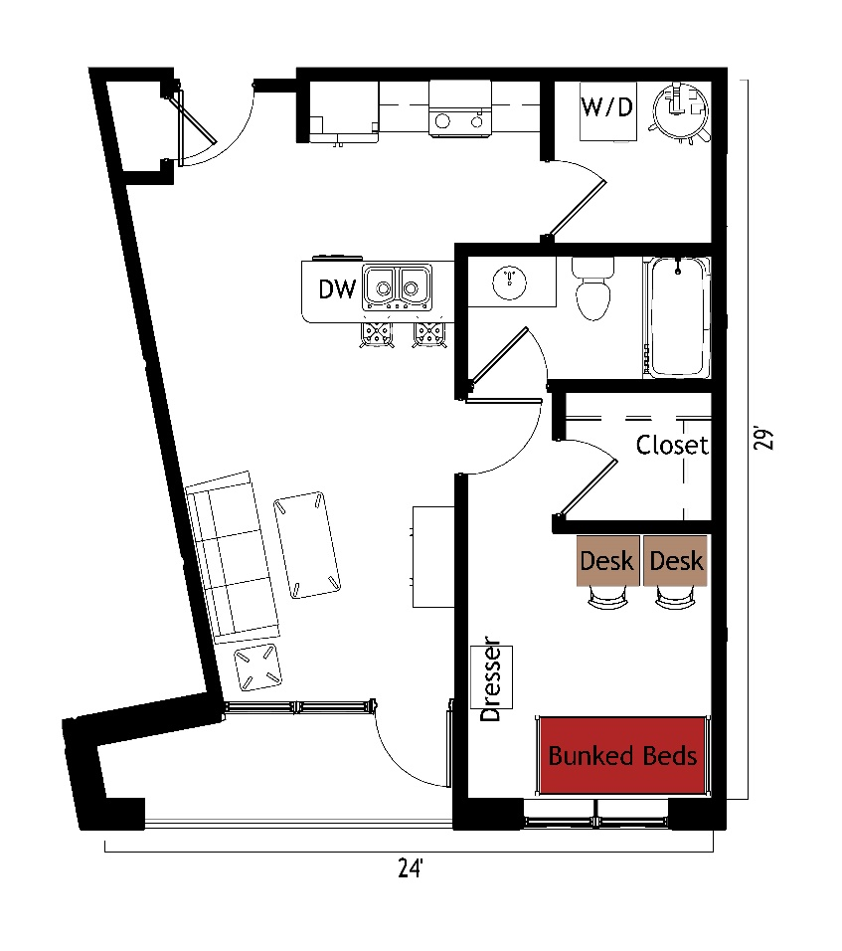
The 1 bedroom for 2 people apartment (Type A2) measures 29 feet by 24 feet. The bedroom, which is shared by 2 students, includes bunked beds, 2 desks, 2 desk chairs, closet and dresser. The apartment has a bathroom with a sink, toilet and shower. There is a living room and kitchen with a couch, coffee table, end table and stools at the kitchen island. The kitchen comes with a refrigerator/freezer, stove, sink, and dishwasher. There is a washer and dryer unit provided in the apartment
Please note: These floorplans give a close approximation of the space, but your unit’s exact size, layout, and furniture arrangement may vary.

