Master Lease: StateHouse Highline

2 people per room with bath in a 3-bedroom apartment-Type C2
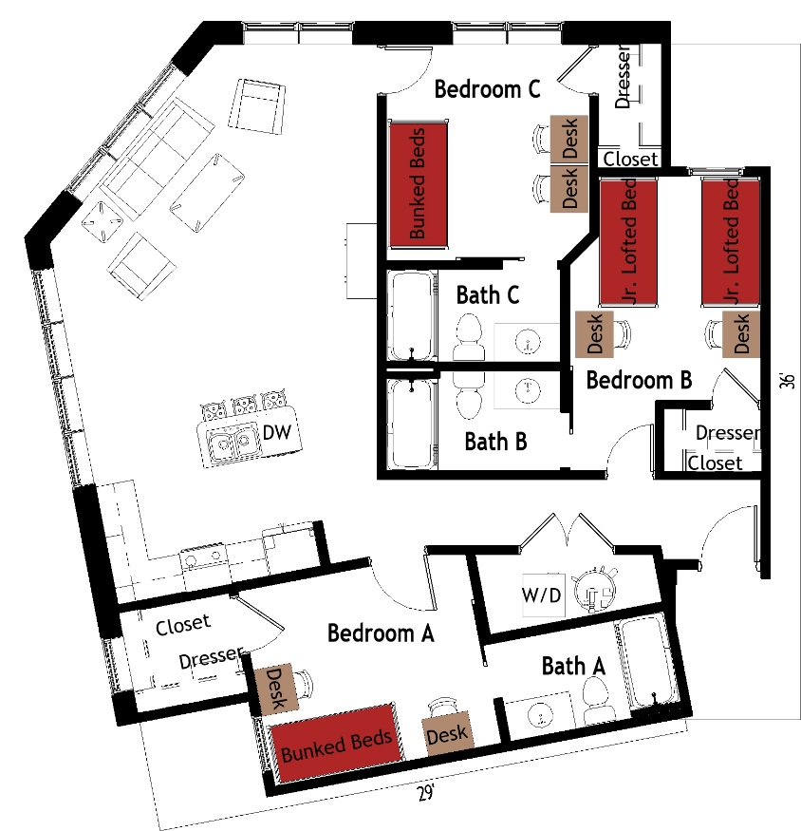

The 2 person per room in a 3-bedroom apartment (Type C2) measures 29 feet by 36 feet. The 3 bedrooms, which are shared by 2 students, include either bunked beds or 2 junior lofted beds, 2 desks, 2 desk chairs, closet and dresser. The apartment has 3 bathrooms with a sink, toilet and shower in each. There is a living room and kitchen with a couch, 2 chairs, coffee table, end table and stools at the kitchen island. The kitchen comes with a refrigerator/freezer, stove, sink, and dishwasher. There is a washer and dryer unit provided in the apartment
Please note: These floorplans give a close approximation of the space, but your unit’s exact size, layout, and furniture arrangement may vary.

