Master Lease: StateHouse Norwich

1 bedroom apartment for 2 people-Type 1
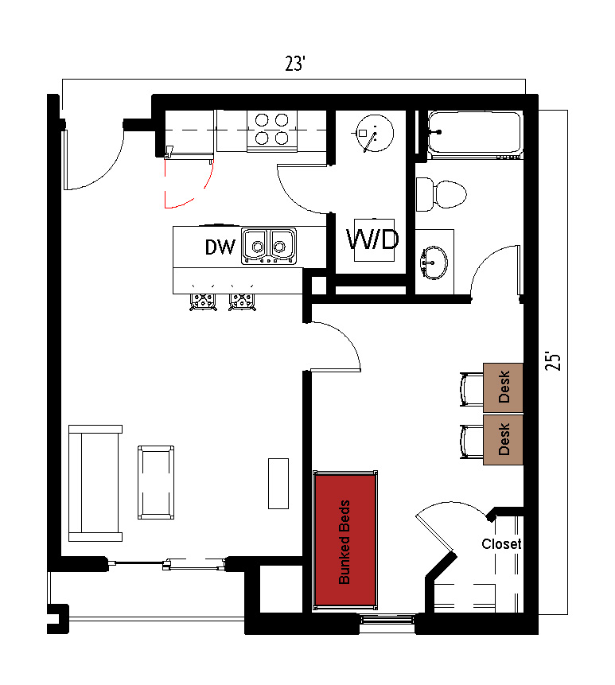
The 2 people per room in a 1-bedroom apartment (Type 1) measures 23 feet by 25 feet. The bedroom, which is shared by 2 students, includes bunked beds, 2 desks, 2 desk chairs, and closet. The apartment has a bathroom with a sink, toilet and shower. There is a living room and kitchen with a couch, coffee table, and stools at the kitchen island. The kitchen comes with a refrigerator/freezer, stove, sink, and dishwasher. There is a washer and dryer unit provided in the apartment
Please note: These floorplans give a close approximation of the space, but your unit’s exact size, layout, and furniture arrangement may vary.

