Master Lease: StateHouse Norwich

2 people per room with bath in a 3-bedroom apartment-Type 3
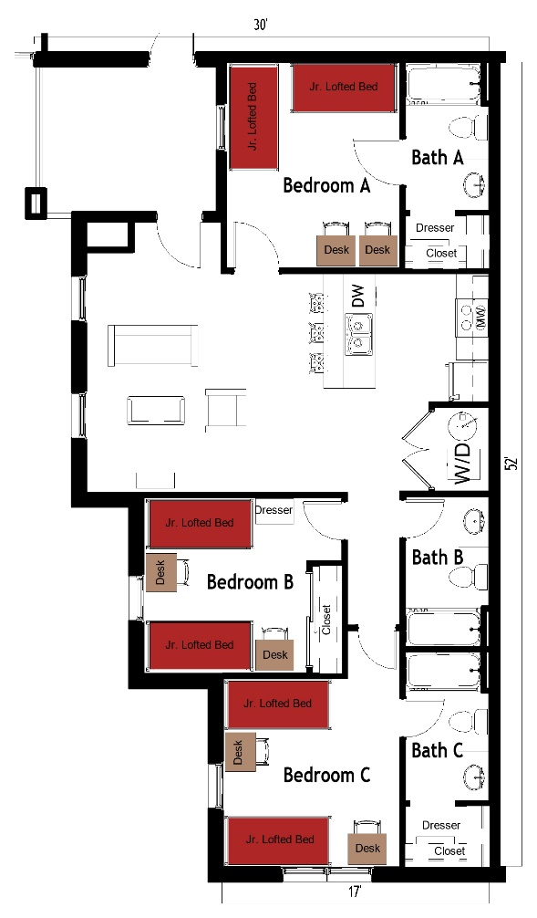

The 2 people per room in a 3-bedroom apartment (Type 3) measures 30 feet by 52 feet. Each bedroom, which is shared by 2 students, includes 2 junior lofted beds, 2 desks, 2 desk chairs, closet and dresser. The apartment has 3 bathrooms, and each bathroom has a sink, toilet and shower. There is a living room and kitchen with a couch, chair, coffee table, and stools at the kitchen island. The kitchen comes with a refrigerator/freezer, stove, sink, and dishwasher. There is a washer and dryer unit provided in the apartment
Please note: These floorplans give a close approximation of the space, but your unit’s exact size, layout, and furniture arrangement may vary.

