Master Lease: StateHouse Norwich

2 people per room with bath in a 4-bedroom apartment-Type 1
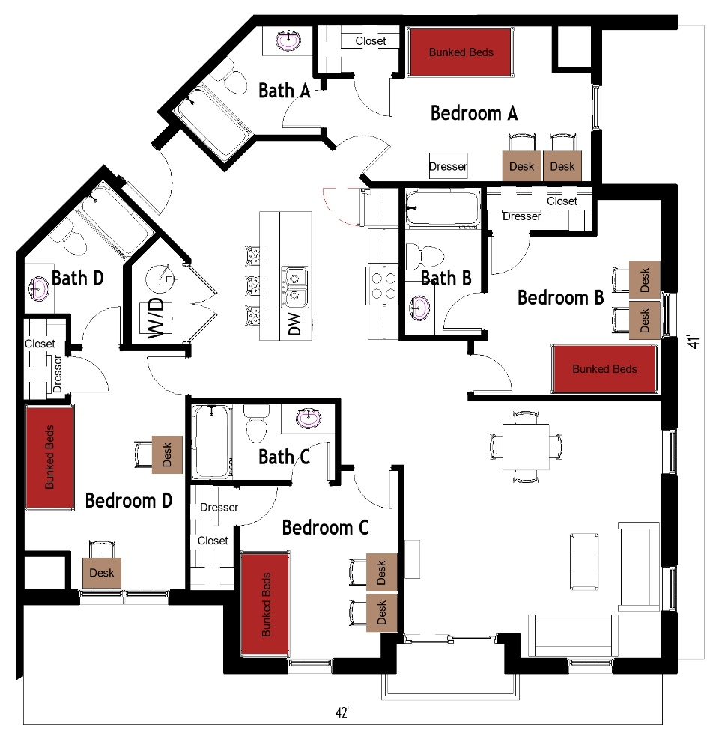

The 2 people per room in a 4-bedroom apartment (Type 1) measures 41 feet by 42 feet. Each bedroom, which is shared by 2 students, includes bunked beds, 2 desks, 2 desk chairs, closet and dresser. The apartment has 4 bathrooms, and each bathroom has a sink, toilet and shower. There is a living room and kitchen with a couch, chair, coffee table, stools at the kitchen island and a table and 4 chairs. The kitchen comes with a refrigerator/freezer, stove, sink, and dishwasher. There is a washer and dryer unit provided in the apartment
Please note: These floorplans give a close approximation of the space, but your unit’s exact size, layout, and furniture arrangement may vary.

