Master Lease: StateHouse Lane

1 bedroom apartment for 2 people-Type 1
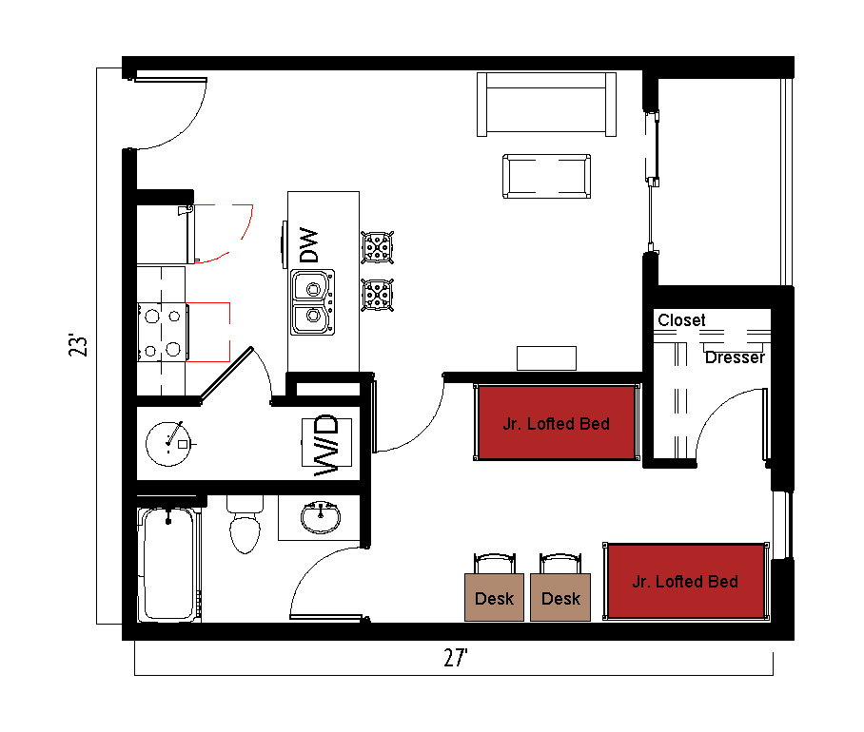
The 1-bedroom apartment for 2 people (Type 1) measures 23 feet by 27 feet. The bedroom which is shared by 2 students includes 2 junior lofted beds, 2 desks, 2 desk chairs, closet and dresser. The bathroom in the apartment has a sink, toilet and shower. There is a living room and kitchen with a couch, coffee table, and stools at the kitchen island. The kitchen comes with a refrigerator/freezer, stove, sink, and dishwasher. There is a washer and dryer unit provided in the apartment
Please note: These floorplans give a close approximation of the space, but your unit’s exact size, layout, and furniture arrangement may vary.

