Master Lease: StateHouse Lane

2 people per room with bath in a 2-bedroom apartment-Type 1
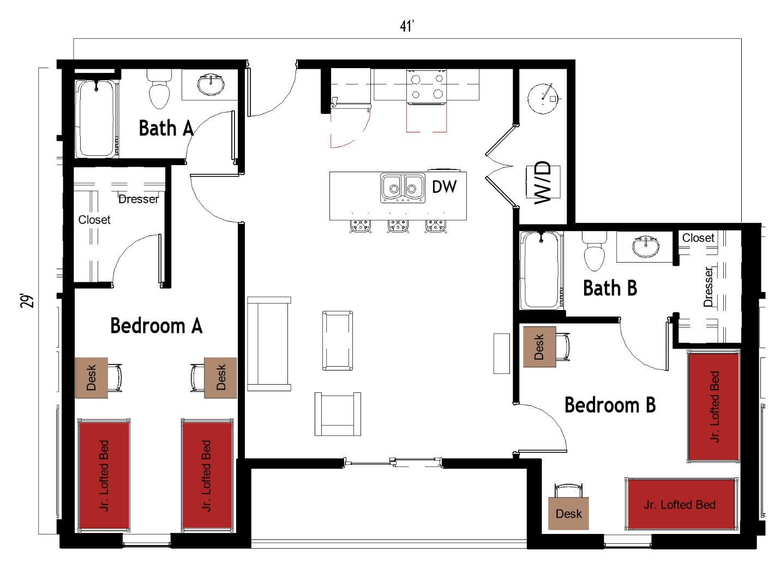

The 2 people per room in a 2 bedroom apartment (Type 1) measures 29 feet by 41 feet. Each bedroom which is shared by 2 students includes 2 junior lofted beds, 2 desks, 2 desk chairs, closet and dresser. The apartment has 2 bathrooms and each bathroom has a sink, toilet and shower. There is a living room and kitchen with a couch, chair, coffee table, and stools at the kitchen island. The kitchen comes with a refrigerator/freezer, stove, sink, and dishwasher. There is a washer and dryer unit provided in the apartment
Please note: These floorplans give a close approximation of the space, but your unit’s exact size, layout, and furniture arrangement may vary.

