Worthington Building

4-person apartment
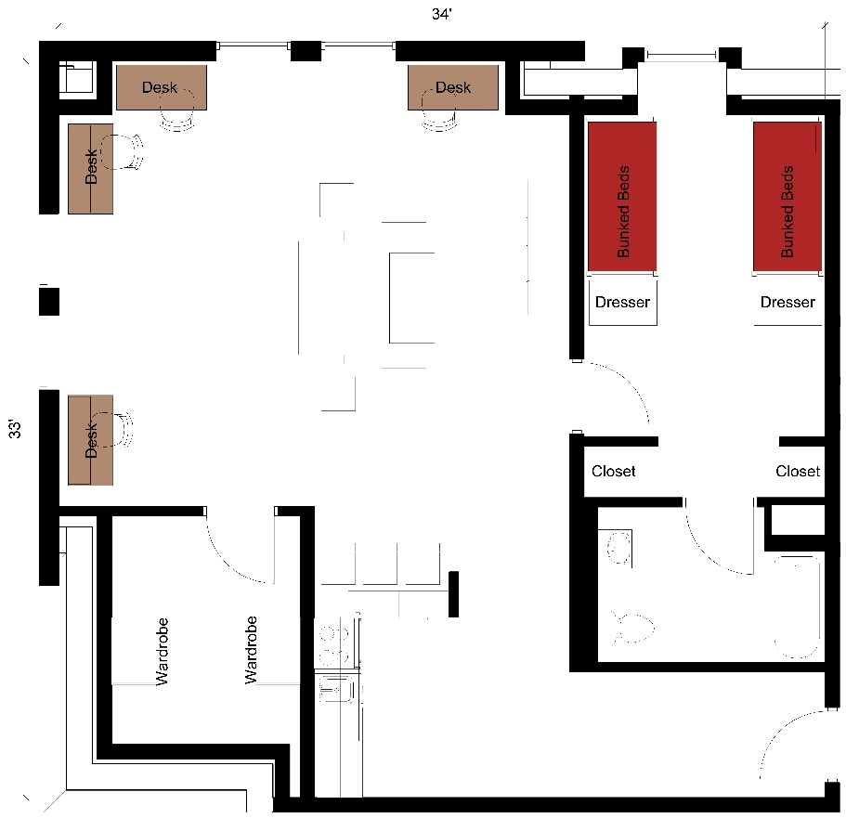
A four-person apartment with approximate dimensions of 33 feet by 34 feet with a living room, bathroom and kitchen and one bedroom included. The apartment has in the bedroom 2 sets of bunked beds, 2 dressers and 2 closets. In the storage room there are 2 wardrobes. The bathroom has a sink, toilet and shower. The living room has 4 desks and desk chairs as well as a couch and 2 chairs. The kitchen comes with a stove, refrigerator/freezer, dishwasher and barstools at the counter.

Please note: These floorplans give a close approximation of the space, but your unit’s exact size, layout, and furniture arrangement may vary.

